

BIM Modelling Manual

Version: 1.1 (Final)

July 2023

© The Government of the Hong Kong Special Administrative Region

The contents of this document remain the property of and may not be reproduced in
whole or in part without the express permission of the Government of the HKSAR

[Blank Page]
Distribution
Copy No. | Holder
1 | Departmental BIM Steering Committee (DBSC):  HQs - AD(T)  Survey Division - CLS  GEO - CGE/LPM2  CEO - CE/PW  EDO - CE/E3  SDO - CE/S3  WDO - CE/W4  NDO - CE/N3  SLO - CE/L1  Survey Division - SLS/BIM
2 | Departmental BIM Working Group (DBWG):  Survey Division - CLS  GEO - SGE/D2  CEO - SE/P5 & SE/3  EDO - SE/23  SDO - SE/PM  WDO - SE/8  NDO - SE/17  SLO - TS  Survey Division - E/BIM

Amendment History
Change Number | Revision Description | Pages Affected on Respective Version | Revision / Version Number | Date | Approval Reference
1 | 1st Draft | All | 0.1 | 23.11.2021
2 | 2nd Draft – Circulation to BSWG | All | 0.2 | 30.11.2021
3 | 3rd Draft – Updated according to Feedback from BSWG | All | 0.3 | 24.12.2021
4 | 1st Final – Circulation to BSSG | - | 1.0 | 14.1.2022
5 | Updated according to new DEVB TC(W) requirements | All | 1.1 | xx.07.2023

List of Abbreviation

Abbreviation Full Expression
2D Two Dimensional
3D Three Dimensional
4D Four Dimensional (i.e. Three Dimensional with Time)
5D Five Dimensional (i.e. Three Dimensional with Time and Cost)
AM Asset Management
AIR Asset Information Requirements
AIM Asset Information Model
BEP BIM Project Execution Plan
BIM Building Information Modelling / Building Information Model
BIM Manager BIM Manager (and the team) appointed in the works
CAD Computer Aid Design
CAT Category Code for BIM matrix model elements
CDE Common Data Environment
BIM CDCP Common Data Collaboration Platform for BIM
CEDD Civil Engineering and Development Department, HKSAR Government
CIC Construction Industry Council, Hong Kong
CMMS Computerized Maintenance Management System
COBie Construction Operation Building Information Exchange
CSDI Common Spatial Data Infrastructure
CSWP CAD Standard for Works Projects
DEVB Development Bureau, HKSAR Government
EIR Exchange Information Requirements
GIS Geographic Information System
IFC Industry Foundation Classes
LandsD Lands Department, HKSAR Government
LOD Level of Development
LOD-G Level of Graphics
LOD-I Level of Information
LOIN Level of Information Need
Project Manager Agency on behalf of the Employer
PIM Project Information Model (Project BIM Model)
PIR Project Information Requirements
Service Manager Agency on behalf of the Employer
QA Quality Assurance
QC Quality Control
TC(W) Technical Circular
WIP Work In Progress
VR Virtual Reality

TABLE OF CONTENTS
List of Abbreviation 1
1. Introduction 1
1.1. Purpose 1
1.2. Structure 1
2. General Planning and Management 2
2.1. Overview 2
2.2. Open Data Format 3
2.3. Standards Management 3
3. Modelling Organisation and Structure 5
3.1. Model Federation 5
3.2. Model Breakdown Structure 10
3.3. Model Naming Convention 34
3.4. Object Naming Convention 43
3.5. Systems Naming Convention 45
4. Modelling Standard 46
4.1. Modelling Principles 46
4.2. Coordinate Systems 48
4.3. Modelling Environment 48
4.4. Annotation, Dimension and Symbol 49
4.5. Colour Convention 49
4.6. LOIN Specification 50
5. Guideline for BIM Process 56
5.1. Common Data Collaboration Platform for BIM (BIM CDCP) 56
5.2. Design Review 57
5.3. 3D Coordination 57
5.4. Drawing Production 58
5.5. Quality Control and Checking 58

ANNEX A: GUIDELINE TO CREATE ATTRIBUTES (LOD-I) IN COMMON BIM SOFTWARE 1
ANNEX B: BIM OBJECT SHEET TEMPLATE 1

Introduction

Purpose

This document serves as the reference manual for the development of all BIM deliverables in the design and construction stage for the CEDD to enhance the collaboration of information and model auditing process. All Project Information Model (PIM) shall be developed as according to the guidelines and standards in this document as far as practicable.

This document may NOT cover all the standards for the as-built models and asset information models. The as-built models and asset information models may require further enhancement according to requirements (asset template and/or Asset Information Requirements) from individual maintenance parties.

This manual shall be updated with the DEVB BIM Harmonisation Guidelines regularly. The BIM Manager shall refer to the section 2.3 in handling conflicts of standards/guidelines.

Structure

Section 2 is a general guide for planning and managing BIM process.

Section 3 specifies a framework for model federation and model breakdown arrangement of CEDD. Object elements are classified into disciplinary model to facilitate the collaboration of information in CEDD. All PIM submitted to CEDD shall follow this framework during the submission of PIM.

Section 4 specifies the minimum modelling standards for the PIM submitted to CEDD. The BIM Manager shall adopt these modelling standards during the preparation of the PIM. Any changes to the modelling standard shall be reported to CEDD for review.

Section 5 is a guideline for BIM process implementation. The BIM Manager may require modifying the process and agreed with the CEDD project officers / Project Manager / Service Manager according to work’s situation.

General Planning and Management

Overview

BIM Process

The BIM is a goal-drive process includes a series of activities:

Definition of objectives

Definition of deliverables and BIM Uses for each objective

Definition of LOIN and Responsibility matrix of each deliverable

BIM modelling, checking and coordination process

Design Review and engineering analysis process

Documentation process

Production/Construction process

As-built modelling for operation and maintenance

In additional to the validation of deliverables, the project team shall actively involve in the process in specification, coordination and reviewing of interim deliverables to ensure the objectives is progressively achieving.

The objectives, deliverables and BIM uses shall be clearly defined in the specification, while the BIM Manager shall review and finalise the procedures, LOIN and deliverable schedules in the BEP. The BIM Manager shall refer to the BEP template in the preparation of the BEP.

Schedule of Delivery

Collaboration of advance information is essential for the BIM implementation. It allows the project stakeholders to participate the production of the deliverables before the key dates according to the project goals and objectives.

The BIM Manager shall propose the amount of adequate information and delivery schedule of the interim deliverables according to the works programme and the specification in the BEP. Examples of interim delivery schedule could be found in the BEP template published by CEDD.

Interim deliverables shall be always shared for the review and coordination among stakeholders with a control data environment, such as a Common Data Environment. To allow effective communication of information, all information should be shared with the naming convention in this manual and meta-data requirement in the ISO19650 local Annex in the CIC BIM standard, version 2.1, 2021.

Open Data Format

Data Interoperability

BIM deliverables or other files shall be submitted in native editable formats and/or other formats specified in the latest version of OGCIO – The HKSARG Interoperability Framework (S18); which include, but not limited to, the following:

Native and editable BIM models and drawings

Open BIM format (.ifc version 4.0)

Design reports, documentations, and drawings (.docx, .xlsx, .pdf)

BIM Project Execution Plan, progress reports, clash reports (.docx, .xlsx, .pdf)

Project Programme Files (.xer, .mpp)

GIS data (.shp, .gml)

Videos (.wmv, .mp4)

Design Review Models (.exe, nwd)

Laser Scanning and Point Cloud data (.las, .xyz, .asc, .e57)

3D Mesh Model (.cesium 3D Tiles, .s3mb, .x3d)

Unless specified by the AIR of the maintenance parties, the asset information shall be submitted according to the attribute fields requirement in BS1192-4:2014 and COBie spreadsheet format.

All the BIM object elements in the PIM must be coded and classified with the OmniClass table 23 system code and table 14 Topography code, as well as their related categories table to support a common classification system for digital data exchange.

Standards Management

Priority of standard

The BIM Manager shall adopt the BIM modelling guidelines and industrial best practice. Reference should be made to the relevant Technical Circular, BIM Harmonisation Guidelines, CEDD BIM Standards, CIC BIM Standards and BS EN ISO 19650 in the following order:
- DEVB TC(W) No. [2/2021] - Adoption of BIM for Capital Works Projects in Hong Kong
- DEVB GC No. [1/2021] - Common Spatial Data Infrastructure for Digital Hong Kong
- DEVB TC(W) No. [8/2021] - BIM Harmonisation Guidelines for Capital Works Projects in Hong Kong
- BIM Modelling Manual published by CEDD
- LOIN Specifications published by CEDD
- Asset Information Requirement published by relevant maintenance parties
- CIC Building Information Modelling Standards – General, Version 2.1 – 2021
- CIC BIM Dictionary, 2021
- CIC Production of Building Information Modelling Object Guide General Requirements, Version 2 - 2021
- Drafting Specification for Engineering Survey, Rev. 3.0/Nov 2014 by Civil Engineering and Development Department
- BS EN ISO 19650-1:2018 Organization and digitization of information about buildings and civil engineering works, including building information modelling (BIM) – Information management using building information modelling, Part 1: Concepts and principles
- BS EN ISO 19650-2:2018 Organization and digitization of information about buildings and civil engineering works, including building information modelling (BIM) – Information management using building information modelling, Part 2: Delivery phase of the assets
- BS EN ISO 19650-3:2020 Organization and digitization of information about buildings and civil engineering works, including building information modelling (BIM). Information management using building information modelling, Part 3: Operational phase of the assets.
- BS EN ISO 19650-5:2020 Organization and digitization of information about buildings and civil engineering works, including building information modelling (BIM). Information management using building information modelling Part 5: Security-minded approach to information management.
- BS 1192-4:2014 Collaborative production of information. Fulfilling employer's information exchange requirements using COBie. Code of Practice
- BS EN 12006-2:2015 Building construction - Organization of information about construction works - Part 2: Framework for classification

Management of Conflicts

The BIM Manager shall document the conflicts and final adopted standard/practice in the BEP.

The BIM Manager shall always report the conflicts discovered to the CEDD survey unit as soon as possible.

Modelling Organisation and Structure

Model Federation

General

The BIM Manager shall federate the PIM into sub-models to allow a centralised management of the disciplinary models in the BIM data repository / CDE system in CEDD. This federation standard shall allow all disciplinary models to be shared, searched, and audited systematically.

A PIM includes the Existing Condition Model and the Proposed Works Model. The existing condition model shall be created according to this manual as far as practicable. The BIM Manager shall review the need of further federating the existing condition model according to the guideline in this section.

There are different federation requirements of the Proposed Works Model for each Service in CEDD. The Proposed Works Model must be federated into disciplinary models according to the classification specified in this section. For large scale (e.g. M4) project with larger size BIM models and/or multiple buildings, the BIM Manager shall further federate the disciplinary models into the further levels according to the guideline in this section.

The federate models at lower levels shall be combined into a single file at the parent level, until all federated models are organized into a single PIM. The BIM Manager shall always submit all the disciplinary models (2nd level) in native and editable format to CEDD together with the combined PIM.

Federation guideline

The BIM Manager shall always ensure the operability of the native PIM files during modelling, viewing, updating, and coordination activities in the works. The BIM Manager shall limit the file size of each native model to 500MB.

Architectural, structural and services systems in buildings/facilities should be federated by building blocks and the last connection manholes. All elements outside building blocks should be grouped into other disciplinary models.

The BIM Manager may further federate the PIM according to the delivery schedule and modelling methodologies / software. Yet, the BIM manger shall avoid the breaking of system connectivity during model federation as far as practicable.

The BIM Manager shall always propose the federation system in the BEP and agreed with CEDD or the Project Manager / Service Manager.

Federation Structure

Object elements in CEDD are grouped into 23 disciplinary models (2nd level federation). A third level federation is setup for the larger scale (M4) project for Land and Infrastructure Services to lower the file size, when necessary.

The BIM Manager shall refer to the naming convention requirements in this manual for each disciplinary model to ensure the PIM is well organised for sharing, auditing, and coordination.

This section summarised the disciplinary models required in each service area. The BIM Manager may always further federate the disciplinary models, as long as they are grouped and submitted as disciplinary models.

Model Federation for Environmental and Sustainability Services
Project Model | 1st Level Federation | 2nd level Federation  (Disciplinary Models) | Description
Project Information Model | Existing Condition Model | Existing Site Topography | Topology (Digital Terrain Model) of the site area, include GI data and bore hole data
Project Information Model | Existing Condition Model | Existing Street Furniture | Relevant existing planters, traffic sign, road markings, railings, street lighting, barriers, kerbs etc
Project Information Model | Existing Condition Model | Existing Structure | All existing above ground and underground structures of the Service area
Project Information Model | Existing Condition Model | Existing Underground Utilities | All existing underground utilities systems of the Service area
Project Information Model | Proposed Works Model | Geotechnical Slope Model | Site boundary, Geological elements, Slope works and related stabilisation system
Project Information Model | Proposed Works Model | Stormwater Model | Proposed Stormwater systems of the Services area
Project Information Model | Proposed Works Model | Sewerage Model | Proposed Sewerage systems of the Service area
Project Information Model | Proposed Works Model | Water Supply Model | Proposed Water Supply systems of the Service area
Project Information Model | Proposed Building Model | Architectural Model | Architectural Elements, finishes of the Service
Project Information Model | Proposed Building Model | Structural Model | Structural Elements of the Service
Project Information Model | Proposed Building Model | Mechanical Model | Plant/Specialised Mechanical Elements of the Service
Project Information Model | Proposed Building Model | Building Services Model | MEP systems of the Service

Model Federation for Geotechnical and Engineering Services
Project Model | 1st Level Federation | 2nd level Federation  (Disciplinary Models) | Description
Project Information Model | Existing Condition Model | Existing Site Topography | Topology (Digital Terrain Model) of the site area, include GI data and bore hole data
Project Information Model | Existing Condition Model | Existing Street Furniture | Relevant existing planters, traffic sign, road markings, railings, street lighting, barriers, kerbs etc
Project Information Model | Existing Condition Model | Existing Structure | All existing above ground and underground structures of the Service area
Project Information Model | Existing Condition Model | Existing Underground Utilities | All existing underground utilities systems of the Service area
Project Information Model | Proposed Works Model | Geotechnical Slope Model | Site boundary, Geological elements, Slope works and related stabilisation system
Project Information Model | Proposed Works Model | Geotechnical Structure Model | Concrete structures, foundations and access elements
Project Information Model | Proposed Works Model | Stormwater Model | Proposed Stormwater systems of the Services area
Project Information Model | Proposed Works Model | Landscape Model | Vegetation, planters, and recreation elements

Model Federation for Port and Marine Services
Project Model | 1st Level Federation | 2nd level Federation  (Disciplinary Models) | Description
Project Information Model | Existing Condition Model | Existing Site Topography | Topology (Digital Terrain Model) of the site area, include GI data and bore hole data
Project Information Model | Existing Condition Model | Existing Street Furniture | Relevant existing planters, traffic sign, road markings, railings, street lighting, barriers, kerbs etc
Project Information Model | Existing Condition Model | Existing Structure | All existing above ground and underground structures of the Service area
Project Information Model | Existing Condition Model | Existing Underground Utilities | All existing underground utilities systems of the Service area
Project Information Model | Proposed Works Model | Fender System Model | Fender systems and related object elements
Project Information Model | Proposed Works Model | Marine Civil Model | Furnitures within marine facilities, including Site boundary, proposed topologies and bathymetry
Project Information Model | Proposed Works Model | Marine Structural Model | Structural elements classified by PWD
Project Information Model | Proposed Works Model | Building Services Model | E&M equipment and related systems and concrete works
Project Information Model | Proposed Works Model | Architectural Model | Architectural elements/fixtures within marine facilities

Model Federation for Land and Infrastructure Service
Project Model | 1st Level Federation | 2nd level Federation  (Disciplinary Models) | 3rd level Federation | Description
Project Information Model | Existing Condition Model | Existing Site Topography | N/A | Topology (Digital Terrain Model) of the site area, include GI data and bore hole data
Project Information Model | Existing Condition Model | Existing Street Furniture | N/A | Relevant existing planters, traffic sign, road markings, railings, street lighting, barriers, kerbs etc
Project Information Model | Existing Condition Model | Existing Structure | N/A | All existing above ground and underground structures of the Service area
Project Information Model | Existing Condition Model | Existing Underground Utilities | N/A | All existing underground utilities systems of the Service area
Project Information Model | Proposed Works Model | Geotechnical Slope Model | N/A | Site boundary, Geological elements, Slope works and related stabilisation system
Project Information Model | Proposed Works Model | Roadworks Model | N/A | Road works systems including traffic systems and related dwarf wall and slope works
Project Information Model | Proposed Works Model | Landscape Model | N/A | Outdoor landscape systems including planting, parks, recreation facilities, etc
Project Information Model | Proposed Works Model | Sewerage Model | N/A | Proposed/Rediverted Sewerage network of the Service
Project Information Model | Proposed Works Model | Stormwater Model | N/A | Proposed/Rediverted Stormwater network of the Service
Project Information Model | Proposed Works Model | Water Supplies Model | N/A | Proposed/Rediverted freshwater supplies network of the Service
Project Information Model | Proposed Works Model | Telecommunications Model | N/A | Proposed/Rediverted Telecommunication system of the Services
Project Information Model | Proposed Works Model | Electrical Power Supply Model | N/A | Proposed/Rediverted Power supply system of the Services
Project Information Model | Proposed Works Model | Gas Supply Model | N/A | Proposed/Rediverted Gas Supply system of the Services
Project Information Model | Proposed Works Model | Highway Structure Model | Sub Structure Model | Underground structure for foundation supports
Project Information Model | Proposed Works Model | Highway Structure Model | Super Structure Model | Above ground structure of highways
Project Information Model | Proposed Works Model | Highway Structure Model | Concrete Structure Model | Other structure such as Tunnel linings
Project Information Model | Proposed Works Model | Specialised Systems Model | Tunnel Ventilation system | Tunnel Ventilation system
Project Information Model | Proposed Works Model | Specialised Systems Model | Tunnel Fire Service System | Tunnel Fire Services System
Project Information Model | Proposed Works Model | Specialised Systems Model | TCSS | Traffic Control and Surveillance System
Project Information Model | Proposed Building(s) Model | Architectural Model | N/A | Architectural elements of each building / plant room /etc
 | Proposed Building(s) Model | Structural Model | N/A | Structure elements of each building / plant room /etc
 | Proposed Building(s) Model | Building Services Model | N/A | MEP elements of each building / plant room /etc

Model Breakdown Structure

General

This Model breakdown structure is defined to ensure the object elements are well-classified into disciplinary models to support the centralise management of BIM data in CEDD. The CEDD shall adopt this classification to audit the compliance of the disciplinary models received from project offices before submitting to the LandsD to develop the CSDI.

The definition of object elements is referring to the OmniClass Classification developed based on ISO 12006-2, Organization of Information About Construction Works – Part 2: Framework for Classification of Information to support the cross-platform integration in the construction industry. The BIM Manager may refer to the description of each object elements according to the Level 3 and Level 4 classification of the Tables 13 and 23 of the OmniClass tables.

The BIM Manager shall always avoid creating the below-defined BIM objects in different disciplinary models. The BIM Manager shall seek advice from the CEDD in case of any unavoidable situation. Any changes of the breakdown structure and the coding convention shall be reported to the CEDD for review and endorsement.

The BIM Manager shall always review the CAT CODE and SUBCAT CODE specification from the BIM Harmonisation Guidelines to determinate the definition of the SUBCAT CODE required. The SUBCAT CODE defines the functional nature of the object elements, multiple* SUBCAT CODE may be applicable to one object (CAT code) depending on its function and features.

This section lists the typical object elements in CEDD and demonstrates how they are classified into disciplinary models of CEDD. The BIM Manager shall always create adequate/further object elements according to the project specification and BIM uses requirements and document the model breakdown detail of each disciplinary model in the BEP for the approval.

Existing Condition Model

Existing Condition Model could be further federated into disciplinary models according to the following structure, if applicable
Project Model | 1st Level Federation | 2nd level Federation  (Disciplinary Models) | Description
Project Information Model | Existing Condition Model | Existing Structure | All existing above ground and underground structures of the Service area
Project Information Model | Existing Condition Model | Existing Site Topography | Topology (Digital Terrain Model) of the site area, include GI data and bore hole data
Project Information Model | Existing Condition Model | Existing Street Furniture | Relevant existing planters, traffic sign, road markings, railings, street lighting, barriers, kerbs etc
Project Information Model | Existing Condition Model | Existing Underground Utilities | All existing underground utilities systems of the Service area

The following object elements shall be grouped and modelled under the Existing Structure, if applicable
ITEM | OBJECT ELEMENT | CAT CODE | SUBCAT CODE | OMNICLASS NO | OMNICLASS DESCRIPTION
1 | Culverts | TCU | Multiple* | 23-11 21 21 11 13 | Concrete Culverts
2 | Existing Building Structure Mass Model | MAS | MAS | 23-19 29 00 | Complete Buildings
3 | Existing Bridge and Tunnel Structure Mass Model | MAS | MAS | 23-39 13 00 | Tunnels and Bridges
4 | Existing Retaining Structure | SRW | ___ | 23-11 17 00 | Retention Structure
5 | Foundation (pile) | SFD | FPL | 23-13 29 11 | Foundation piles
6 | Foundation  (pile cap) | SFD | FCA | 23-13 29 11 11 21 | Pile Caps
7 | Foundation  (ground beam) | SFD | FBM | 23-13 29 15 13 | Grade Beams (shallow foundations)
8 | Foundation (Other) | SFD | Multiple* | 23-13 29 00 | Foundations
9 | Footing | SFD | OTR | 23-13 29 15 15 | Strip Foundation Blocks (shallow foundations)
10 | Mass Concrete Infill (including No-fines Concrete) | GSM | MAC | 23-13 15 11 | Concretes
11 | Retaining Wall on Slope | SUS | RET | 23-11 17 13 | Retaining Walls
12 | Concrete Beam,Steel Beam, Hanger | BEM | ___ | 23-13 35 11 | Structural Frames
13 | Structural Wall | SWL | ___ | 23-13 31 11 | Structural Concrete
14 | Structural Columns | SCL | Multiple* | 23-13 35 11 | Structural Frames
15 | Floor, Slab | SLA | ___ | 23-13 31 11 | Structural Concrete
16 | Steel access ladder | GSM | SAL | 23-17 23 15 | Ladders
17 | Steel Handrailing (to Maintenance Stairway on Slope) | GSM | SRL | 23-17 25 13 | Handrails
18 | Steel Staircase (Maintenance Stairway on Slope) | GSM | SST | 23-17 23 17 11 | Stair component products
19 | Steel Gate | GSM | SGA | 23-17 23 17 11 21 | Stair Barrier Gates
20 | Maintenance Access (incl. Concrete Stairway/Berm) | GSM | CMS | 23-13 31 17 | Concrete Formwork
21 | Diaphragm Wall | EXL | DIW | 23-11 17 00 | Retention Structures
22 | Lining | UCL | Multiple* | 23-39 13 11 15 | Tunnel Lining
23 | Tunnel Structure Segments | TIS | Multiple* | 23-39 13 11 | Tunnels
24 | Temp. Support Structure | EXL | Multiple* | 23-11 11 00 | Ground Anchorages
25 | Chain Link Fence on Slope | GSM | CLF | 23-11 25 19 19 | Chain Link Metal Fences

The following object elements shall be grouped and modelled under the Existing Site Topography, if applicable
ITEM | OBJECT ELEMENT | CAT CODE | SUBCAT CODE | OMNICLASS NO | OMNICLASS DESCRIPTION
1 | Terrain (Bathymetry) | DTM | BAE | 14-34 17 99 | Other Land and Water Topographical Transitions
2 | Land Lot Boundary | LOT | LAN | 14-37 11 11 | Parcel
3 | Terrain (Rock head) | DTM | ROK | 14-31 99 00 | Other Space Designations to facilitate design and construction
4 | Terrain (Shoreline / Beach Finish Level) | DTM | BFL | 12-34 17 24 | Shoreline
5 | Terrain (Site Topology) | DTM | TOP | 14-37 11 14 | Site
6 | Tree / Vegetation | LTP | Multiple* | 23-11 27 19 13 | Trees
7 | Man-made slope (Registered) | GSM | MMS | 14-34 11 00 | Slopped Topographical spaces
8 | Natural slope | GSM | NSL | 14-34 11 00 | Slopped Topographical spaces
9 | Site/Slope Boundary Polygon | LOT | SIT | 14-37 11 14 | Site
10 | Borehole | GEO | BOH | N/A | N/A
11 | Fill | GEO | FIL | N/A | N/A
12 | Marine deposits | GEO | MAD | N/A | N/A
13 | Alluvium | GEO | ALL | N/A | N/A
14 | Colluvium | GEO | COL | N/A | N/A
15 | Residual Soil | GEO | RES | N/A | N/A
16 | Completely decomposed rock | GEO | CDR | N/A | N/A
17 | Highly decomposed rock | GEO | HDR | N/A | N/A
18 | Bedrock | GEO | BED | N/A | N/A
19 | Compacted Fill | GEO | COF | N/A | N/A

The following object elements shall be grouped and modelled under the Existing Street Furniture, if applicable
ITEM | OBJECT ELEMENT | CAT CODE | SUBCAT CODE | OMNICLASS NO | OMNICLASS DESCRIPTION
1 | Barrier | FBF | Multiple* | 23-39 11 11 15 | Traffic Barrier
2 | Bollard at Road | FBL | Multiple* | 23-39 11 19 | Bollards
3 | Catchpit | SCH | ___ | 23-39 29 13 19 11 | Surface Water Catch Basins, Grates and Frames
4 | Pavement | RCT | PAV | 23-11 21 00 | Pavements
4a | Carriageway | RCW | Multiple* | 23-11 21 13 | Roadways
4b | Cycle Track | RCT | Multiple* | 23-11 21 00 | Pavements
4c | Footpath | RFW | Multiple* | 23-11 21 00 | Pavements
5 | E&M Pit /  Cable Draw Pit | ECD | ___ | 23-17 11 27 23 | Manhole Accesses
6 | Bus Shelter / Terminus | FST | Multiple* | 23-19 29 13 | Covers and Shelters
7 | Electric Pole | SIT | ETP | 23-39 23 11 11 | Electrical Utility Poles
8 | Electric Transformer | ETR | Multiple* | 23-35 13 11 | Current Transformers
9 | Exterior Benches / Seating | SIT | SIT | 23-11 29 13 | Exterior Seating
10 | Fence | FBF | Multiple* | 23-11 25 19 | Fences
11 | Fire Hydrant | FS_ | SFH | 23-29 25 13 | Fire Hydrants
12 | Fire Valve | PPA | VLV | 23-29 25 13 | Fire Hydrants
13 | Gate | FEG | Multiple* | 23-11 25 15 | Perimeter Gates
14 | Grating | GRA | Multiple* | 23-39 29 15 | Waste Water Channels, Gullies, Gratings, Covers
15 | Guard Rails/ Railings | FRA | Multiple* | 23-17 25 11 | Guardrails
16 | Gully | GUL | Multiple* | 23-39 29 15 | Waste Water Channels, Gullies, Gratings, Covers
17 | Hoarding | EHO | Multiple* | 23-11 25 13 | Perimeter Walls
18 | Inspection Chamber | ECD | ___ | 23-17 11 27 23 | Manhole Accesses
19 | Lamp Post / Lighting column/ Lighting pole | LLP | Multiple* | 23-35 47 11 21 23 | Street and Roadway Lighting Fixture
20 | Planter | LTW | SHS | 23-11 27 13 | Planting Accessories
21 | Road Kerbs | RKB | Multiple* | 23-39 11 11 19 | Roadways Curbs
22 | Road Marking | RMK | Multiple* | 23-39 11 15 11 | Roadway Surface Markings
23 | Sign Pole/Traffic sign | FTS | Multiple* | 23-39 11 13 | Roadway Signage
24 | Staircase | TTE | ___ | 23-17 23 17 11 | Stair Component Products
25 | Street Name Plate | FNP | Multiple* | 23-11 29 33 | Exterior Directional Signs
26 | Telephone Pole | SIT | TEP | 23-37 11 17 | Communication Wireways
27 | Traffic Light | FTL | Multiple* | 23-39 11 15 17 | Traffic Signals
28 | U-Channel/  Covered U-Channels | SUP | ___ | 23-11 21 21 15 | Channels
29 | Sand Trap | SPH | ___ | 23-39 29 11 17 | Wastewater Pipework Access Fittings
30 | Storm Water Manhole cover | SMC | Multiple* | 23-39 29 13 19 15 | Storm Drainage Manholes, Frames, and Covers
31 | Baffle | GSM | BAF | 23-11 17 00 | Retention Structures
32 | Raking Drains | GSM | RKD | 23-11 13 11 23 | Field Drainage Blocks
33 | Soil Nail | GSM | SON | 23-11 11 13 11 | Earth Reinforcement Soil nails
34 | Stepped Channel | SSP | Multiple* | 23-11 21 21 15 | Channels
35 | Flexible Barrier | GSM | FBR | 23-11 19 00 | Slide and Avalanche Protection
36 | Rigid barrier | GSM | RBR | 23-11 17 00 | Retention Structures
37 | Hard Surface Cover  (e.g. shotcrete) | GSM | HSC | 23-11 13 11 | Soil stabilization products
38 | Recreation area/facilities | LOT | REA | 23-11 31 00 | Athletic and Recreational Surfaces
39 | Vegetation Surface Cover | GSM | VSC | 23-11 13 11 | Soil stabilization products
40 | Tree Ring | GSM | TRR | 23-11 27 13 | Planting Accessories
41 | Erosion Control Mat | GSM | ECM | 23-11 15 11 21 | Sheeting Synthetic Erosion Controls
42 | Wire Mesh | GSM | WRM | 23-13 19 11 15 | Mesh for General Use
43 | Ground Anchors | GSM | GAR | 23-11 11 11 | Retaining Stabilizing Ground Anchors
44 | Concrete Cover for Channels | SUP | SUC | 23-39 29 15 | Waste Water Channels, Gullies, Gratings, Covers
45 | Cast Iron Grating for Channels | SUP | SUG | 23-39 29 15 | Waste Water Channels, Gullies, Gratings, Covers

The following object elements shall be grouped and modelled under the Existing Underground Utilities, if applicable
ITEM | OBJECT ELEMENT | CAT CODE | SUBCAT CODE | OMNICLASS NO | OMNICLASS DESCRIPTION
1 | Manhole | UMH | ___ | 23-17 11 27 23 | Manhole Accesses
2 | Manhole Foul Water / Sewer | FMH | Multiple* | 23-39 29 11 13 | Waste Water Storm Drain
3 | Manhole Storm Water | SMH | Multiple* | 23-39 29 13 19 15 | Storm Drainage manholes, frames and covers
4 | Manhole Telephone | MTL | ___ | 23-17 11 27 23 | Manhole Accesses
5 | Valve Gas | PPA | VLV | 23-39 25 11 | Gas Utility Pipeline Equipment
6 | Valve Waterworks | PPA | VLV | 23-39 27 11 | Water Utility Pipeline Equipment
7 | Power cables / lines | EPD | ___ | 23-35 33 25 | Electrical Wireway
8 | Gas pipe | GAP | ___ | 23-39 25 11 | Gas Utility Pipeline Equipment
9 | Telecommunication lines | TED | ___ | 23-37 11 17 | Communication Wireways
10 | Sewage Pipe | FWD | ___ | 23-39 29 11 15 | Waste Water Drainage pipe, couplings, Collectors
11 | Storm Water pipe | SWD | ___ | 23-39 29 13 19 11 | Surface Water Catch Basins, Grates and Frames
12 | Fresh Watermain | WSD | ___ | 23-39 27 11 | Water Utility Pipeline Equipment
13 | Salt Watermain | SSD | ___ | 23-39 27 11 | Water Utility pipeline equipment
14 | Box Culvert | SBP | ___ | 23-11 21 21 11 13 15 | Concrete Box Culverts
15 | Chamber | SBH | Multiple* | 23-39 29 13 19 17 | Surface water retention chamber
16 | Inlet | SIH | ___ | 23-39 29 13 19 13 | Combination storm drain and underdrain inlets
17 | Nullah | SNP | ___ | 23-11 21 21 15 | Channels

Proposed Civil Infrastructure Works Model

Proposed Works should be further federated into disciplinary models according to the following structure, if applicable

Project Model | 1st Level Federation | 2nd level Federation  (Disciplinary Models) | Description
Project Information Model | Proposed Works Model | Fender System Model | Fender systems and related object elements in port and marine facilities
Project Information Model | Proposed Works Model | Geotechnical Slope Model | Site boundary, Geological elements, Slope works and related stabilisation system
Project Information Model | Proposed Works Model | Geotechnical Structure Model | Concrete structures, foundations and access elements in slope works
Project Information Model | Proposed Works Model | Highway Structure Model | Underground structure for foundation supports
Project Information Model | Proposed Works Model | Highway Structure Model | Above ground structure of highways
Project Information Model | Proposed Works Model | Highway Structure Model | Other structure such as Tunnel linings, portals, etc
Project Information Model | Proposed Works Model | Landscape Model | Outdoor landscape systems including planting, parks, recreation facilities, etc
Project Information Model | Proposed Works Model | Marine Civil Model | Furnitures within marine facilities, including site boundary, proposed topologies and bathymetry
Project Information Model | Proposed Works Model | Marine Structure Model | Structural elements in port and marine facilities
Project Information Model | Proposed Works Model | Roadworks Model | Road works systems including roadworks and related dwarf wall, retaining structure, slope works and site boundary
Project Information Model | Proposed Works Model | Sewerage Model | Proposed/Rediverted Sewerage network of the Service
Project Information Model | Proposed Works Model | Specialised Systems Model | Tunnel Ventilation system
Project Information Model | Proposed Works Model | Specialised Systems Model | Tunnel Fire Services System
Project Information Model | Proposed Works Model | Specialised Systems Model | Traffic Control and Surveillance System
Project Information Model | Proposed Works Model | Stormwater Model | Proposed/Rediverted Stormwater network of the Service
Project Information Model | Proposed Works Model | Water Supply Model | Proposed/Rediverted freshwater supplies network of the Service
Project Information Model | Proposed Works Model | Gas Supply Model | Proposed/Rediverted Gas Supply system of the Services
Project Information Model | Proposed Works Model | Electrical Power Supply Model | Proposed/Rediverted Power supply system of the Services
Project Information Model | Proposed Works Model | Telecommunications Model | Proposed/Rediverted Telecommunication system of the Services

The Fender System Model includes all the object elements in the fendering system proposed in the works for the Port and Marine services. The following object elements should be included:
ITEM | OBJECT ELEMENT | CAT CODE | SUBCAT CODE | OMNICLASS NO | OMNICLASS DESCRIPTION
1 | Capping (Rubber or Timber) | FEN | FCA  (PWD Code) | 23-39 21 11 11 13 | Boat Fenders
2 | Chain for Fender System | FEN | FCH | 23-39 21 11 11 13 | Boat Fenders
3 | Eye blot for Fender System | FEN | FEB | 23-39 21 11 11 13 | Boat Fenders
4 | Frontal Pad | FEN | FFP | 23-39 21 11 11 13 | Boat Fenders
5 | Horizontal Fender  (plastic, timber, rubber) | FEN | FHF | 23-39 21 11 11 13 | Boat Fenders
6 | Horizontal/Inclined fender wailing | FEN | FVF/FIW | 23-39 21 11 11 13 | Boat Fenders
7 | Rubber Buffer | FEN | FRB | 23-39 21 11 11 13 | Boat Fenders
8 | Step Block (Rubber or Timber) | FEN | FSB | 23-39 21 11 11 13 | Boat Fenders
9 | Steel Bracket | FEN | FBK | 23-39 21 11 11 13 | Boat Fenders
10 | Steel Plate for Wailing system | FEN | FSP | 23-39 21 11 11 13 | Boat Fenders
11 | Vertical Fender  (plastic, timber, rubber) | FEN | FVF | 23-39 21 11 11 13 | Boat Fenders

The Geotechnical Slope Model include the geological object elements proposed in the works for Geotechnical and Engineering services. The following object elements should be included:
ITEM | OBJECT ELEMENT | CAT CODE | SUBCAT CODE | OMNICLASS NO | OMNICLASS DESCRIPTION
1 | Baffle | GSM | BAF | 23-11 17 00 | Retention Structures
2 | Earthwork (cut/fill)  (for slopeworks) | SUS | Multiple* | 23-11 13 11 17 | Soil Stabilization Fill
3 | Flexible barrier net, shackle for net, round clip | GSM | FBR | 23-11 19 00 | Slide and Avalanche Protection
4 | Flexible Barrier Post, Base plate, Footing, shackle on post, running wheel | GSM | FBR | 23-11 19 00 | Slide and Avalanche Protection
5 | Flexible barrier cable rope, rope clip, braking element | GSM | FBR | 23-11 19 00 | Slide and Avalanche Protection
6 | Man-made slope (Registered) | GSM | MMS | 14-34 11 00 | Slopped Topographical spaces
7 | Natural slope | GSM | NSL | 14-34 11 00 | Slopped Topographical spaces
8 | Raking Drains | GSM | RKD | 23-11 13 11 23 | Field Drainage Blocks
9 | Rigid barrier | GSM | RBR | 23-11 17 00 | Retention Structures
10 | Soil Nail | GSM | SON | 23-11 11 13 11 | Earth Reinforcement Soil nails
11 | Site/Slope Boundary Polygon | LOT | SIT | 14-37 11 14 | Site
12 | Terrain (Site  formation) | DTM | TSF | 14-37 11 14 | Site
13 | Geological model
13a | Borehole | GEO | BOH | N/A | N/A
13b | Fill | GEO | FIL | N/A | N/A
13c | Compacted Fill | GEO | COF | N/A | N/A
13d | Design Groundwater profile | GEO | GRW | N/A | N/A
14 | Ground anchors | GSM | GAR | 23-11 11 11 | Retaining Stabilizing Ground Anchors
15 | Gabion for Rigid Barrier | GSM | GAB | 23-11 17 15 | Gabions
16 | Cushioning Material for Rigid Barrier | GSM | CUM | 23-11 00 00 | Site Products
17 | Steel Grating for Rigid Barrier | GSM | GRA | 23-39 29 15 | Waste Water Channels, Gullies, Gratings, Covers
18 | Tree Ring | GSM | TRR | 23-11 27 13 | Planting Accessories
19 | Erosion Control Mat | GSM | ECM | 23-11 15 11 21 | Sheeting Synthetic Erosion Controls
20 | Wire Mesh | GSM | WRM | 23-13 19 11 15 | Mesh for General Use

The Geotechnical Structure Model includes the structural object elements proposed in the works in Geotechnical and Engineering services. The following object elements should be included:
ITEM | OBJECT ELEMENT | CAT CODE | SUBCAT CODE | OMNICLASS NO | OMNICLASS DESCRIPTION
1 | Foundation (pile) | SFD | FPL | 23-13 29 11 | Foundation piles
2 | Foundation  (pile cap) | SFD | FCA | 23-13 29 11 11 21 | Pile Caps
3 | Foundation  (ground beam) | SFD | FBM | 23-13 29 15 13 | Grade Beams (shallow foundations)
4 | Footing | SFD | OTR | 23-13 29 15 15 | Strip Foundation Blocks (shallow foundations)
5 | Mass Concrete Infill (including No-fines Concrete) | GSM | MAC | 23-13 15 11 | Concretes
6 | Retaining Wall on Slope | SUS | RET | 23-11 17 13 | Retaining Walls
7 | Structural concrete beam | GSM | BEM | 23-13 35 11 | Structural Frames
8 | Structural concrete wall | GSM | SWL | 23-13 31 11 | Structural Concrete
9 | Structural concrete column | GSM | SCL | 23-13 35 11 | Structural Frames
10 | Structural concrete slab | GSM | SLA | 23-13 31 11 | Structural Concrete
11 | Structural steel column, post | GSM | SCL | 23-13 35 11 | Structural Frames
12 | Steel access ladder | GSM | SAL | 23-17 23 15 | Ladders
13 | Temporary work, temporary structure, platform | GSM | TMW | 23-23 25 00 | Scaffolding
14 | Steel Handrailing (to Maintenance Stairway on Slope) | GSM | SRL | 23-17 25 13 | Handrails
15 | Steel Staircase | GSM | SST | 23-17 23 17 11 | Stair component products
16 | Steel Gate | GSM | SGA | 23-17 23 17 11 21 | Stair Barrier Gates
17 | Maintenance Access (incl. Concrete Stairway/Berm) | GSM | CMS | 23-13 31 17 | Concrete Formwork
18 | Foundation (Other) | SFD | Multiple* | 23-13 29 00 | Foundations
19 | Chain Link Fence on Slope | GSM | CLF | 23-11 25 19 19 | Chain Link Metal Fences
20 | Skin Wall | GSM | SWL | 23-13 00 00 | Structural and Exterior Enclosure Products

Highways Structural Model includes all the structural object elements proposed in the works for road, tunnels, and highways construction . It is applicable to all services. The following object elements should be included:
ITEM | OBJECT ELEMENT | CAT CODE | SUBCAT CODE | OMNICLASS NO | OMNICLASS DESCRIPTION
1 | Super structure model: Bridge
1a | Abutment | TBR | AOR | 23-13 31 11 | Structural Concrete
1b | Bearings | TBR | BEA | 23-39 13 13 19 | Bridge Bearings
1c | Deck/Segment | TBR | DEC | 23-39 13 13 23 | Bridge Decking
1d | Girder/main beams/webs | TBR | GOM | 23-39 13 13 13 | Bridge beams
1e | Pier/Column/Soffit | TBR | COP/SOF | 23-13 31 11 | Structural Concrete
2 | Noise Enclosure System
2a | Noise Enclosure | TNE | Multiple* | 23-39 11 11 13 |  | Noise Barriers
2b | Noise Barrier | TNB | Multiple* | 23-39 11 11 13 |  | Noise Barriers
3 | Super structure model: Footbridge
3a | Abutment | TFB | AOR | 23-13 31 11 | Structural Concrete
3b | Bearings | TFB | BEA | 23-39 13 13 19 | Bridge Bearings
3c | Deck/Segment | TFB | DEC | 23-39 13 13 23 | Bridge Decking
3d | Girder/main beams/webs | TFB | GOM | 23-39 13 13 13 | Bridge beams
3e | Pier/Column/Soffit | TFB | COP | 23-13 31 11 | Structural Concrete
3f | Staircases (bridge) | TFB | ROS | 23-17 23 17 11 | Stair components products
3g | Roof and skylights (bridge) | TFB | ROO | 23-13 39 11 | Exterior Roof Panels
3h | Lift Tower (Bridge) | TLT | Multiple* | 23-13 31 11 | Structural Concrete
4 | Sub- Structure Model
4a | Pile | SFD | FPL | 23-13 29 11 | Foundation piles
4b | Pile Cap | SFD | PCA | 23-13 29 11 11 21 | Pile Caps
4c | Cable Trench | CTF | CHN | 23-13 31 11 | Structural Concrete
4d | Excavation and refill for sub-structure | EXL | BAF | 23-11 13 11 17 | Soil Stabilization Fill
4e | Foundation | Multiple* | Multiple* | 23-13 29 00 | Foundation
5 | Other Structural elements
5a | Diaphragm Wall | EXL | DIW | 23-11 17 00 | Retaining Structures
5b | Lining | UCL | Multiple* | 23-39 13 11 15 | Tunnel Lining
5c | Tunnel Structure Segments | TIS | Multiple* | 23-39 13 11 | Tunnels
5d | Panel Wall | UPL | PW_ | 23-13 35 21 19 | Structural Panels
5e | Temp. Support Structure | EXL | Multiple* | 23-11 11 00 | Ground Anchorages

Landscape Model includes all the object elements for the landscaping works proposed in the works. It is applicable to all services. The following object elements should be included:
ITEM | OBJECT ELEMENT | CAT CODE | SUBCAT CODE | OMNICLASS NO | OMNICLASS DESCRIPTION
1 | Barrier | FBF | Multiple* | 23-39 11 11 15 | Traffic Barrier
2 | Bollard | FBL | Multiple* | 23-39 11 19 | Bollards
3 | Hard Surface Cover  (e.g. shotcrete) | GSM | HSC | 23-11 13 11 | Soil stabilization products
4 | Lighting | LSL | Multiple* | 23-35 47 11 21 23 | Street and Roadway Lighting Fixture
5 | Planter (including planter for slope) | LTW | SHS | 22-11 27 13 | Planting Accessories
6 | Railing / Handrail | FRA | Multiple* | 23-17 25 11 | Guardrails
7 | Recreation area/facilities | LOT | REA | 23-11 31 00 | Athletic and Recreational Surfaces
8 | Retaining Wall Finishes | DTL | FIN | 23-13 00 00 | Structural and Exterior Enclosure Products
9 | Signage / Traffic Sign | FTW | Multiple* | 23-39 11 13 | Roadway signage
10 | Sign Gantry | VRS | ___ | 23-39 11 13 | Roadway signage
11 | Tree (New plant) | LTP | Multiple* | 23-11 27 19 13 | Trees
12 | Vegetation Surface Cover | GSM | VSC | 23-11 13 11 | Soil stabilization products

Marine Civil Model includes the following object elements proposed in the works for the Port and Marine services. The following object elements should be included:
ITEM | OBJECT ELEMENT | CAT CODE | SUBCAT CODE | OMNICLASS NO | OMNICLASS DESCRIPTION
1 | Access/Cat Ladder | ALA | CAL | 23-17 23 15 11 | Vertical Ladders
2 | Terrain (Proposed Profile or Tunnel Seabed Levels) | DTM | BAP | 14-34 17 24 | Shoreline
3 | Barrier Bollard | SIT | CBB | 23-39 11 19 | Bollards
4 | Bench | SIT | CBN | 23-11 29 13 11 | Exterior Benches
5 | Concrete Plinth | SFD | CCP | 23-13 31 15 | Precast Structural Concrete
6 | Fence | SIT | CFC | 23-11 25 19 | Fences
7 | Gate | SIT | CGT | 23-11 25 11 | Perimeter Entry Devices
8 | Lifebuoy | SIT | CLB | 23-29 00 00 | Facility and Occupant Protection products
9 | Marine Notice Board | SIT | CMN | 23-19 11 17 | Notice Board
10 | Mooring eye | FEN | CME | 23-39 21 11 11 11 | Mooring Post
11 | Mooring Bollard | FEN | CBO | 23-39 21 11 11 11 | Mooring Post
12 | Navigation Light Post | SIT | CNL | 23-39 21 17 13 | Navigation Lights
13 | Pier Notice board | SIT | CNB | 23-19 11 17 | Notice Board
14 | Terrain (Site formation) | DTM | TSF | 14-34 17 99 | Other Land and Water Topographical Transitions
15 | Railing/Handrail | FRA | Multiple* | 23-17 25 11 | Guardrails
16 | Signage/information plate (include landing /structural no. plate, pier) | SIT | CSG | 23-19 11 11 | Information Signs
17 | Step iron | FEN | CSI | 23-39 21 11 11 11 | Mooring Post
18 | Site Boundary Polygon | LOT | SIT | 14-37 11 14 | Site
19 | Tidal Gauge House | SIT | CGH | 23-13 31 15 | Precast Structural Concrete
20 | Tidal Gauge Tubes | SIT | CTG | 23-27 11 21 23 | Level Sensors

The Marine Structure Model includes all the object elements in the structural elements in the Port and Marine services proposed in the works. The following object elements should be included:
ITEM | OBJECT ELEMENT | CAT CODE | SUBCAT CODE | OMNICLASS NO | OMNICLASS DESCRIPTION
1 | Terrain (Shoreline / Beach Finish Level) | DTM | BFL | 12-34 17 24 | Shoreline
2 | Pile Cap | MSF | SPC | 23-13 29 11 11 21 | Pile Caps
3 | Pile Foundation | MSF | SPI | 23-13 29 11 11 | Foundation Piles
4 | Concrete Foundation for Beacon | MSF | SCF | 23-13 29 15 15 | Strip Foundation Blocks
5 | Anchor Blot/Post | MSF | SAB | 23-13 35 19 | Rafters, Beams and Joists
6 | Structural Beam (Concrete Beam, Steel Beam and Tie Beam) | MSF | SBM | 23-13 35 11 13 13 | Beams
7 | Structural Column  (Concrete Column,  Steel Column and Post) | MSO | SCL | 23-13 35 11 13 11 | Column
8 | Bracing (Horizontal/Vertical) | MSF | SBH  /SBV | 23-13 35 19 | Rafters, Beams and Joists
9 | Slab/Pier Deck | MSO | SLA | 23-15 17 13 19 | Precast Tile and Slab Flooring
10 | Precast Beam Slab Panel | MSO | SPP | 23-13 31 15 | Precast Structural Concrete
11 | Ramp | MSO | SRP | 23-17 23 11 | Ramps
12 | Corbel/Concrete Bracket for Pier | MSO | SCO | 23-13 29 00 | Structural Foundation
13 | Structural wall / retaining wall | MSO | SWL | 23-13 35 21 11 | Concrete structural wall
14 | Concrete structure for Beacon, Dolphin, vertical seawall, and a solid pier | MSF | SCS | 23-13 31 11 | Structural Concrete
15 | Steel structure for Beacon | MSO | SSS | 23-39 21 11 11 | Navigation components
16 | Access Structure | MSO | SAC | 23-13 35 23 11 | Structural Concrete floor decks
17 | Landing Platform | MSO | SLP | 23-13 35 23 11 | Structural Concrete floor decks
18 | Landing Staircase Structure | MSO | SLS | 23-13 31 11 | Structural Concrete
19 | Landing Step | MSO | SLT | 23-13 31 11 | Structural Concrete
20 | Concrete Coping | MSF | SCC | 23-13 31 11 | Structural Concrete
21 | Gabion Wall | MSO | SGW | 23-11 17 15 | Gabions
22 | Wave Absorption Chamber | MSO | SWA | 23-13 31 11 | Structural Concrete
23 | Precast Concrete Block  (include seawall block, solid pier concrete block, wave wall/barrier) | MSO | SBK | 23-13 31 15 | Precast Structural Concrete
24 | Rock Armour for seawall and  breakwater | MSO | SRA | 23-39 21 15 13 | Seawalls
25 | Rock Fill | MSO | SRF | 23-13 11 13 | Aggregates
26 | Berm Stone | MSO | SBS | 23-13 21 11 | Concrete Masonry Units
27 | Bagged Concrete | MSO | SBC | 23-13 21 11 | Concrete Masonry Units
28 | Levelling Stone | MSO | SLV | 23-13 11 13 | Aggregates
29 | Pell Mell Rubble | MSO | SPM | 23-13 11 13 | Aggregates

The Roadworks Model includes all object elements of the road works proposed in the works. It is applicable to all services. The following object elements should be included:
ITEM | OBJECT ELEMENT | CAT CODE | SUBCAT CODE | OMNICLASS NO | OMNICLASS DESCRIPTION
1 | Earthwork (Cut/Fill) | SUS | Multiple* | 23-11 13 11 17 | Soil Stabilization Fill
2 | Kerb | RKB | Multiple* | 23-39 11 11 19 | Roadway Curbs
3 | Man-made slope  (for road construction) | SRS/SUS | Multiple* | 23-11 13 11 17 | Soil Stabilization Fill
4 | Pavement
4a | Carriage way | RCW | Multiple* | 23-11 21 13 | Roadways
4b | Cycle Track | RCT | Multiple* | 23-11 21 00 | Pavements
4c | Foot path | RFW | Multiple* | 23-11 21 00 | Pavements
5 | Retaining Structure | SFD | DWL | 23-11 17 00 | Retaining Structures
6 | Road Marking | RMK | Multiple* | 23-39 11 15 11 | Roadway Surface Markings
7 | Site Boundary Polygon | LOT | SIT | 14-37 11 14 | Site
8 | Traffic Island- Other | RIO | Multiple* | 23-39 11 11 19 | Roadway Curbs
9 | Traffic Island- Refuge Island | RIR | Multiple* | 23-39 11 11 19 | Roadway Curbs
10 | Terrain (Roadworks) | DTM | SIT | 14-37 11 14 | Site

The Sewerage Model include all the object elements of the Sewerage works proposed in to works. It is applicable to all services. The following object elements should be included:
ITEM | OBJECT ELEMENT | CAT CODE | SUBCAT CODE | OMNICLASS NO | OMNICLASS DESCRIPTION
1 | Box Culvert (Sewerage) | FBP | ___ | 23-11 21 21 11 13 15 | Concrete Box Culverts
2 | Chamber | FCH | ___ | 23-39 29 11 15 | Waste water drainage pipes, couplings, collectors
3 | Rising Main | FRM | ___ | 23-39 29 11 15 | Waste water drainage pipes, couplings, collectors
4 | Sewerage Manhole | FMH | Multiple* | 23-39 29 11 13 11 | Waste water storm drain manhole
5 | Sewerage Manhole Cover | FMC | Multiple* | 23-39 29 11 13 13 | Waste water storm drain man hole cover
6 | Sewerage Gravity Sewer | FWD | ___ | 23-39 29 11 15 | Waste water drainage pipes, couplings, collectors
7 | Special Manhole | FSH | Multiple* | 23-39 29 11 13 11 | Waste water storm drain manhole
8 | Terminal Manhole | FLH | Multiple* | 23-39 29 11 13 11 | Waste water storm drain manhole
9 | Tunnel (Sewerage) | FTP | ___ | 23-11 21 21 11 13 15 | Concrete Box Culverts

The Specialised Systems Model includes all the object elements of the electrical, mechanical and control system required in the roads, tunnels and highways proposed in to works. It is applicable to all services. The following object elements should be included:
ITEM | OBJECT ELEMENT | CAT CODE | SUBCAT CODE | OMNICLASS NO | OMNICLASS DESCRIPTION
1 | TCSS | SPQ | ___ | 23-39 11 15 17 | Traffic Signals
2 | Tunnel Ventilation System | UFC | Multiple* | 23-29 27 00 | Fire Ventilation Equipment

The Stormwater Model includes all the object elements of storm water drains proposed in the works. It is applicable to all services. The following object elements should be included
ITEM | OBJECT ELEMENT | CAT CODE | SUBCAT CODE | OMNICLASS NO | OMNICLASS DESCRIPTION
1 | Box Culvert | SBP | ___ | 23-11 21 21 11 13 15 | Concrete Box Culverts
2 | Catchpit | SCH | ___ | 23-39 29 13 19 11 | Surface Water Catch Basins, Grates and Frames
3 | Chamber | SBH | Multiple* | 23-39 29 13 19 17 | Surface water retention chamber
4 | Decked Nullah | SDP | ___ | 23-11 21 21 15 | Channels
5 | Inlet | SIH | ___ | 23-39 29 13 19 13 | Combination storm drain and underdrain inlets
6 | Nullah | SNP | ___ | 23-11 21 21 15 | Channels
7 | Outlet | SNF | ___ | 23-39 29 13 | Waste water subdrainage
8 | Gully | GUL | Multiple* | 23-39 29 15 | Waste water channels, gullies, gratings, covers
9 | Gully Pipe | SWD | ___ | 23-39 29 13 17 | Subgrade drains
10 | Sand Trap | SPH | ___ | 23-39 29 11 17 | Wastewater Pipework Access Fittings
11 | Stepped Channel | SSP | Multiple* | 23-11 21 21 15 | Channels
12 | Stormwater manhole cover | SMC | Multiple* | 23-39 29 13 19 15 | Storm drainage manholes, frames and covers
13 | Stormwater manhole | SMH | Multiple* | 23-39 29 13 19 15 | Storm drainage manholes, frames and covers
14 | Stormwater pipe | SWD | ___ | 23-39 29 13 17 | Subgrade drains
15 | Terminal manhole | SLH | Multiple* | 23-39 29 13 19 15 | Storm drainage manholes, frames and covers
16 | U-Channel/  Covered U-Channels | SUP | ___ | 23-11 21 21 15 | Channels
17 | Concrete Cover for Channels | SUP | SUC | 23-39 29 15 | Waste water channels, gullies, gratings, covers
18 | Cast Iron Grating for Channels | SUP | SUG | 23-39 29 15 | Waste water channels, gullies, gratings, covers

The Water Supply Model includes all the object elements of the water supplies network proposed in the works. It is applicable to all services. The following object elements should be included
ITEM | OBJECT ELEMENT | CAT CODE | SUBCAT CODE | OMNICLASS NO | OMNICLASS DESCRIPTION
1 | Fresh watermain | WSD | ___ | 23-39 27 11 | Water Utility pipeline equipment
2 | Salt Watermain | SSD | ___ | 23-39 27 11 | Water Utility pipeline equipment
3 | Chamber /Pump Pit | SBH | Multiple* | 23-39 27 11 | Water Utility pipeline equipment
4 | Fittings | PPF | Multiple* | 23-39 27 11 | Water Utility pipeline equipment
5 | Valve | PPA | VLV | 23-27 31 00 | Valves
6 | Thrust Block | THB | ___ | 23-39 27 11 | Water Utility pipeline equipment
7 | Fire Hydrant | FS_ | SFH | 23-29 25 13 | Fire Hydrants

The Gas Supply Model includes all the object elements of the gas utilities proposed in the works. It is applicable to all services. The following object elements should be included
ITEM | OBJECT ELEMENT | CAT CODE | SUBCAT CODE | OMNICLASS NO | OMNICLASS DESCRIPTION
1 | Gas Pipe | GAP | ___ | 23-39 25 11 | Gas Utility Pipeline Equipment
2 | Gas Inspection pit | GIP | ___ | 23-17 11 27 23 | Man Hole Accesses
3 | Gas Value | PPA | VLV | 23-27 31 00 | Valves

The Electrical Power Supply Model includes all the object elements of the electrical utilities proposed in the works. It is applicable to all services. The following object elements should be included
ITEM | OBJECT ELEMENT | CAT CODE | SUBCAT CODE | OMNICLASS NO | OMNICLASS DESCRIPTION
1 | Electric Box | ELQ | Multiple* | 23-39 23 00 | Electrical Utility Equipment
2 | Electric Inspection pit | EIP | ___ | 23-17 11 27 23 | Man Hole Accesses
3 | Electric Manholes | EMH | ___ | 23-17 11 27 23 | Man Hole Accesses
4 | Power Cables / lines | EPD | ___ | 23-35 33 25 | Electrical Wireway
5 | Transformers | ETR | ___ | 23-39 23 11 | Electrical Transmission Equipment

The Telecommunication Model includes all the object elements of the telecommunication systems proposed in the works. It is applicable to all services. The following object elements should be included
ITEM | OBJECT ELEMENT | CAT CODE | SUBCAT CODE | OMNICLASS NO | OMNICLASS DESCRIPTION
1 | Telecommunication lines | TED | ___ | 23-37 11 17 13 | Telecommunication Wireways
2 | Tel Inspection pit | TIP | ___ | 23-17 11 27 23 | Man Hole Accesses
3 | Tel Manholes / Drawpits | TMN | ___ | 23-17 11 27 23 | Man Hole Accesses

Proposed Building Works Model

Proposed Works should be further federated into disciplinary models according to the following structure, if applicable
Project Model | 1st Level Federation | 2nd level Federation  (Disciplinary Models) | Description
Project Information Model | Proposed Building Model(s) | Architectural Model | Architectural elements of each building / plant room /etc in the service
Project Information Model | Proposed Building Model(s) | Structural Model | Structure elements of each building / plant room /etc in the service
Project Information Model | Proposed Building Model(s) | Building Services Model | MEP elements of each building / plant room /etc in the service
Project Information Model | Proposed Building Model(s) | Mechanical Model | Specialise mechanical equipment/systems/plants in the service

The Architectural Model includes all the object elements designed by architects in proposed in the buildings/facilities. It is applicable to all services. The following object elements should be included.
ITEM | OBJECT ELEMENT | CAT CODE | SUBCAT CODE | OMNICLASS NO | OMNICLASS DESCRIPTION
1 | Access Ladders and Catwalks | ALA | CAT | 23-17 23 15 13 | Vertical Ladders
2 | Architectural Wall | TWL | Multiple* | 23-15 13 19 | Wall Panels
3 | Blue Colour Paint | MAO | ABP | 23-15 21 11 13 | Textured Paints
4 | Ceiling | CEL | ___ | 23-15 13 21 | Ceiling Panels
5 | Curtain wall/ glass wall | CTP | Multiple* | 23-13 33 19 11 | Cladding and Curtainwall Panels
6 | Door/Entrance | ADO | Multiple* | 23-13 33 21 | Entrances
7 | Elevator / Lift Shaft space | MCO | SHF | 23-19 29 11 11 11 | Lift Shaft Components
8 | Finishes | DTL | FNH | 23-13 00 00 | Structural and Exterior Enclosure Products
9 | Floor, Slab | TLA | Multiple* | 23-15 17 13 | Floor covering strips, Tiles, Blocks and slabs
10 | Furniture | FUR | Multiple* | 23-21 00 00 | Furnishing, Fixture and Equipment Products
11 | Gate | AGT | Multiple* | 23-21 35 21 | Security and Vault Equipment and Furnishings
12 | Louvers | WDW | LVR | 23-17 21 11 15 | Exterior Louvers and Grilles
13 | Mass concrete fill | SFD | OTR | 23-13 15 11 | Concretes
14 | Non-Slip Yellow Nosing | MAO | AYN | 23-15 17 11 15 15 | Slip Resistant floor Treatment
15 | Precast Facade | TWL | TFC | 23-13 33 19 | Precast Concrete Façade
16 | Railing, handrail | FRA | Multiple* | 23-17 25 11 | Guardrails
17 | Ramp | TPD | ROS | 23-17 23 11 | Ramps
18 | Roof /  Architectural Roof | Multiple* | ROO | 23-13 39 11 | Exterior Roof Panels
19 | Roof Gutter |  | AGT | 23-13 41 33 | Roof Gutters
20 | Skylight | WDW | SKY | 23-17 17 00 | Skylights
21 | Stairs | TTE | ___ | 23-17 23 17 | Stairs
22 | Tactile Warning strip | FWS | Multiple* | 23-11 21 13 15 | Detectable Warning Surface for Roadways
23 | Window | WDW | Multiple* | 23-17 13 00 | Windows

Structural Model includes all the object elements designed by structural engineers in proposed in the buildings/facilities. It is applicable to all services. The following object elements should be included.
ITEM | OBJECT ELEMENT | CAT CODE | SUBCAT CODE | OMNICLASS NO | OMNICLASS DESCRIPTION
1 | Base Plates, Blots, clip angles, fixing etc. | SFM | BRA | 23-13 35 19 | Rafters, Beams, Joists
2 | Beams | TBS | Multiple* | 23-13 35 11 13 13 | Beams
3 | Columns | SCL | Multiple* | 23-13 35 11 13 11 | Columns
4 | Foundation (Pile, pile cap, ground  beams & Footings) | SFD | Multiple* | 23-13 29 00 | Foundations
5 | Mass concrete fill | SFD | OTR | 23-13 15 11 | Concretes
6 | Slabs | TLA | Multiple* | 23-15 17 13 19 | Precast tile and slab flooring
7 | Ramp | TPD | ROS | 23-17 23 11 | Ramps
8 | Stairs | TTE | ___ | 23-17 23 17 | Stairs
9 | Structural Wall | TWL | Multiple* | 23-13 35 21 | Structural Walls
10 | Tank structures | SFD | ___ | 23-27 29 13 | Tank Foundation

The Building Services Model includes all the object elements designed by building services engineers in proposed in the buildings/facilities. It is applicable to all services. The following object elements should be included.
ITEM | OBJECT ELEMENT | CAT CODE | SUBCAT CODE | OMNICLASS NO | OMNICLASS DESCRIPTION
1 | MVAC System
1a | Exhaust (extract) air duct | BDU | ___ | 23-33 49 13 | Ventilation Ducts
1b | Fresh air duct | BDU | ___ | 23-33 49 13 | Ventilation Ducts
1c | Return air duct | BDU | ___ | 23-33 49 13 | Ventilation Ducts
1d | Supply air duct | BDU | ___ | 23-33 49 13 | Ventilation Ducts
1e | Access panel | AAP | ___ | 23-33 49 15 | Duct Access Panels
1f | Air handling unit | BAC | ___ | 23-33 25 00 | Air Handling Units
1g | Chillers | MCQ | CHR | 23-33 21 13 | Chillers
1h | Chilled water supply pipe | MCQ | CHL | 23-33 00 00 | HVAC Specific Products and Equipment
1i | Chilled water return pipe | MCQ | CHL | 23-33 00 00 | HVAC Specific Products and Equipment
1j | Condensate drainpipe | MPI | PVC | 23-33 00 00 | HVAC Specific Products and Equipment
1k | Damper | BDA | Multiple* | 23-33 29 00 | HVAC Dampers
1l | Diffuser, air-boot, air grill, air  filter, register | BDI | EXH | 23-33 49 11 | Ventilation Diffusers
1m | Fan | BFA | Multiple* | 23-33 31 19 | Fans
1n | Fan Coil Unit | BFC | ___ | 23-33 33 11 | Fan Coil Unit
1o | Fire damper | BDA | FIR | 23-33 29 23 | Fire Dampers
1p | Insulation | PIS | NA | 23-33 49 17 | Duct Insulation
1q | Primary air unit | BAC | ___ | 23-33 39 00 | Air Conditioning Equipment
1r | Silencer | BSI | ___ | 23-33 00 00 | HVAC Specific Products and Equipment
1s | Smoke extraction system | MCQ | VCS | 23-39 27 11 | Firs Fighting Smoke Extractors
1t | Variable control damper | BDA | VOC | 23-33 29 37 | Volume Control Dampers
1u | Dynamic envelope in MVAC  model | DNE | ___ | 23-33 00 00 | HVAC Specific Products and Equipment
2 | Plumbing System
2a | Flush water piping | PLM | DRN | 23-31 35 00 | Plumbing Tubing
2b | Fresh water piping (water supplies) | WSD | ___ | 23-31 35 00 | Plumbing Tubing
2c | Tap, faucet | PLM | TAP | 23-31 11 00 | Faucets
2d | Valve | MVA | Multiple* | 23-31 00 00 | Plumbing Specific Products and Equipment
2e | Dynamic envelope in plumbing & water supply model | DNE | ___ | 23-31 00 00 | Plumbing Specific Products and Equipment
3 | Drainage and Sewerage
3a | Floor drain | DTH | ODR | 23-31 27 00 | Floor Drains
3b | Gully, sealed trapped gully, clean outs and vent | GUL | Multiple* | 23-31 27 15 | Floor Drains cover
3c | Kitchen waste pipe work including floor drain, open trapped | MPA | Multiple* | 23-31 35 00 | Plumbing Tubing
3d | Rainwater, storm water pipe, storm drain, drainage downpipe | STP | ___ | 23-13 41 39 19 | Siphonic Roof Drains
3e | Rainwater outlet | SNF | ___ | 23-13 41 39 11 | Roof Downspouts
3f | Surface channel, slot channel, external drainage | SUP | DSC | 23-13 41 39 17 | Eavestroughs
3g | Sewerage pipe, foul sewer drains | FWD | CSU | 23-27 39 00 | Piping
3h | Vent pipe | MPI | PVC | 23-27 39 00 | Piping
3i | Dynamic envelope in drainage & sewage model | DNE | ___ | 23-31 00 00 | Plumbing Specific Products and Equipment
4 | Fire Services System
4a | Fire Alarm Control Panel | BFP | Multiple* | 23-29 31 13 | Fire Alarm Control Panel
4b | Fire Alarm Audio/ Visual | BFS | Multiple* | 23-29 31 19 | Combination Audible and Visible Fire Notification Devices
4c | Fire Alarm Devices | ALM | Multiple* | 23-29 31 00 | Fire Notification Appliances
4d | Break glass unit | BFB | ___ | 23-29 29 11 | Fire Alarm Pull stations
4e | Fire detection system, heat or smoke detectors | BFD | Multiple* | 23-29 29 13 | Fire Detectors
4f | Fire hydrant/hose reel system | BFH | ___ | 23-29 25 00 | Fire Fighting Equipment
4g | Sprinkler pipe work | SRK | ___ | 23-29 33 00 | Fire suppression System Components
4h | Sprinkler head | SRK | ___ | 23-29 33 00 | Fire suppression System Components
4i | Sprinkler valve & flow switch | SRK | ___ | 23-29 33 00 | Fire suppression System Components
4j | Dynamic envelope fire services model | DNE | ___ | 23-29 33 00 | Fire suppression System Components
5 | Electrical System / MEP System for Marine and Ports
5a | Cable Draw pit | ECD | Multiple* | 23-17 11 27 23 | Manhole Accesses
5b | CCTV Camera | BCA | Multiple* | 23-29 11 11 13 | Visual Light wavelength CCTV Camera
5c | Corrosion Monitoring Pit | CSE | Multiple* | 23-17 11 27 23 | Manhole Accesses
5d | Corrosion Monitoring Terminal Box | CSE | Multiple* | 23-17 11 27 23 | Manhole Accesses
5e | Directional Exit Sign | BFX | ___ | 23-35 47 15 | Exit Illuminated Signs
5f | Earthing and Lightning equipment | Multiple* | ___ | 23-35 39 00 | Electric Power protection Devices
5g | Electrical Cable tray, cable containment, power feed, cable ducting | CTF | Multiple* | 23-35 33 19 | Electrical Cable Trays
5h | Emergency lighting | BLF | ___ | 23-35 47 13 | Emergency Lighting
5i | Exit sign | BFX | ___ | 23-35 47 15 | Exit Illuminated Signs
5j | GovWifi equipment | CSE | Multiple* | 23-37 13 17 | Wide Area Network Devices
5k | ICCP Transformer Rectifier | ETR | Multiple* | 23-80 50 00 | Terminals for Power supply
5l | Inspection manhole | UMH | ___ | 23-17 11 27 23 | Manhole Accesses
5m | Light fitting/Lighting | BLF | Multiple* | 23-34 47 11 | Lighting Fixtures
5n | Panel board, motor control center | ECP | ___ | 23-35 31 13 | Distribution Panel Boards
5o | Pillar box (including ICCP AC power supply pillar box and electric pillar box) | ETR | Multiple* | 23-80 50 00 | Terminals for Power supply
5p | Sensors | CSE | Multiple* | 23-27 11 00 | General Instrument
5q | Solar Panel | CSE | SOP | 23-75 10 27 17 | Solar Collector Units
5r | Trucking, bus duct, busbar, busway | CTF | CHN | 23-35 33 21 | Electrical Bus ducts
5s | Dynamic envelope electrical  model | DNE | ___ | 23-35 47 00 | Electrical Lighting

Mechanical Model includes all the object elements designed for special plants / facilities in proposed in the buildings/facilities. It is applicable to all Environmental and Sustainability services. The BIM Manager should propose the object elements in the BEP accordingly.
ITEM | OBJECT ELEMENT | CAT CODE | SUBCAT CODE | OMNICLASS NO | OMNICLASS DESCRIPTION
1

Model Naming Convention

General

All PIM submitted to CEDD shall comply with the model naming requirements in the BIM Harmonisation Guidelines published by DEVB, while the AIM submitted to CEDD shall compile with the Asset Information Requirement (AIM) of the maintenance department. This naming convention is one of the essential requirements for the collaboration and auditing of BIM models among CEDD and Works Department.

The BIM Manager could extend this system in naming project specific sub-disciplinary model (starting at the third level federation) using the field 5.2 and the sub-disciplinary code available in the BIM Harmonisation Guidelines. The BIM Manager shall adopt the code in the BIM Harmonisation Guidelines as far as practicable. In case of unavoidable, the BIM Manager shall report the CEDD for further coordination and approval.

This naming convention aligns with the naming convention under the “CIC BIM Standards - General: Version 2.1, 2021” (with Hong Kong Local Annex of ISO 196502:2018).

Definition of Fields

The PIM and all disciplinary models shall be named according to the BIM Harmonisation Guidelines with 7 fields in the following format:
Project_Code, Originator, Volume_System, Location_SubLocation, Discipline_SubDiscipline, Type_Characteristic, SequentialNo

The definitions of 7 fields (and their sub-fields) are defined in below table:
Field No. | Information  Container ID | Subfield  No. | Information Container ID Field Description | Obligation | Field Length and Format | Nature of Code
1 | Project | N/A | A unique identifier for each project. The project number of CEDD should be adopted. | Required | 1-8 alphanumeric | Project Specific
2 | Originator | N/A | A unique identifier based on Agent Responsible Code (ARC)*. This is used to indicate the model’s responsible authoring party.  Investigation and feasibility stage: the ARC of design consultants or CEDD division/offices/units should be adopted.  Detail Design Stage: the ARC of each design consultants or CEDD division/offices/units should be adopted.  Construction Stage: the ARC of each independent design consultants, main contractors, and sub-contractors should be adopted.  *The ARC is updated from time to time, which could be found in the link: https://www.devb.gov.hk/en/construction_sector_matters/electronic_services/cad_standard/computer_aided_drafting/cad/index.html | Required | 3 alphanumeric | Common  (Agent Responsible Codes)
3 | Volume  (and System when applicable) | 3.1 | A unique ID of Hong Kong 1:20000 topographic map index is in this field to define the geospatial zone of the project area. For disciplinary models spanning across multiple maps, the smaller number map index should always be used. | Required | 1-3 alphanumeric | Common  (Index Number of Hong Kong 1:20000 topographic map)
3 | Volume  (and System when applicable) | 3.2 | An identifier to indicate a collection of interconnected model elements across main disciplines under a system (e.g. sewerage system, water supply system, highway). System is used to facilitate data sharing instead of creating multiple interdisciplinary data sets. System codes listed in Section 3.3.3 should be used in this field, whenever applicable. | Required | 1-3 alphanumeric | Common  (appendix X of BIM harmonisation guide)
4 | Location (and Sub-location when  applicable) | 4.1 | An identifier to indicate a project specific location (e.g. 4-digit slope number in GEO, alignment name, Marine number in PWD, feature code, building code) for geospatial coordination and future asset management. Common abbreviation codes should be used as far as practicable.  The BIM Manager should list the definition of project specific location codes in the BEP. | Required | 1-4 alphanumeric | Project Specific
4 | Location (and Sub-location when  applicable) | 4.2 | An identifier to indicate a sub-location (e.g. level, slope portion in GEO, Marine facility type code in PWD) within the same location. Additional sub-locations, if any, should be defined in the project information standard. This field’s value should not duplicate that of Field 4.1.  The BIM Manager should list the definition of project specific sub-location codes in the BEP. | Optional  (Required for GEO & PWD) | 1-2 alphanumeric | Common (Appendix X, Table App X-3 and X-4 of BIM harmonisation guide)
5 | Discipline (and Subdiscipline  when  applicable) | 5.1 | An identifier to define each primary discipline to facilitate appearance settings and information filtering for interdepartmental coordination and auditing. Disciplinary codes listed in Section 3.3.4 should be used in this field. | Required | 1-2 alphabetic | Common  (appendix X of BIM harmonisation guide)
5 | Discipline (and Subdiscipline  when  applicable) | 5.2 | An identifier to indicate each sub-discipline of the disciplinary models. It is used for sub-disciplinary model at level 3 federation. | Optional | 1-2 alphabetic | Common  (appendix X of BIM harmonisation guide)
6 | Type (and  Characteristic  when  applicable) | 6.1 | An identifier to indicate the information held within the file/model. Type codes listed in Section 3.3.5 should be used in this field. | Required | 1-2 alphabetic | Common  (appendix X of BIM harmonisation guide)
6 | Type (and  Characteristic  when  applicable) | 6.2 | An identifier to indicate the model’s characteristic. Type code listed in Section 3.3.5 should be used in this field. | Required | 1 alphabetic | Common  (appendix X of BIM harmonisation guide)
7 | Sequential Number | 7 | A sequential number is assigned when it is necessary to further distinguish the model from the others. | Optional | 3 numeric | Project Specific

The maximum total length of model names is 43 characters (including delimiters and information dividers; excluding file extension).

Hyphen (-, also known as minus) should be used as the delimiter to separate information container ID fields.

Underscore ( _ ) should be used as an information divider between the sub-fields within each field when applicable.

When optional field is not required, it should be left empty, and the preceding delimiter “-“ (hyphen) or information divider “_” (underscore) should be eliminated.

Space, special symbols and invalid characters (including: ~ " # % & * : < > ? / \ { | } .) should not be used within information container IDs.

The universal codes of ZZ and XX for required information container ID fields shall be used when the conditions below exist. For example:

ZZ – multiple exist within a BIM model.

XX – none or not applicable.

System Code

The system code is mandatory in CEDD to allow the easy identification of information owner during the sharing of BIM models. CEDD adopts the system codes and the principle specified in the BIM Harmonisation Guidelines.

The following table provides a guideline for applying the system code to CEDD’s disciplinary Models.

Codes | Definition in BIM Harmonisation Guidelines | Applicable in CEDD Disciplinary Models | Information Owner
BD | Buildings | Architectural Model in Buildings | ArchSD / EMSD / WSD / DSD
BD | Buildings | Building Services Model in Buildings | ArchSD / EMSD / WSD / DSD
BD | Buildings | Structural Model in Buildings | ArchSD / EMSD / WSD / DSD
BD | Buildings | Mechanical Model in Building | ArchSD / EMSD / WSD / DSD
BD | Buildings | Roadworks Model in Building | ArchSD / EMSD / WSD / DSD
BD | Buildings | Electrical Power Supply model in Building works | ArchSD / EMSD / WSD / DSD
BD | Buildings | Gas Supply Model in Building works | ArchSD / EMSD / WSD / DSD
BD | Buildings | Telecommunication Model in Building works | ArchSD / EMSD / WSD / DSD
BD | Buildings | Stormwater Model in Building works | ArchSD / EMSD / WSD / DSD
BD | Buildings | Sewerage Model in Building works | ArchSD / EMSD / WSD / DSD
BD | Buildings | Water Supplies Model in Building works | ArchSD / EMSD / WSD / DSD
FO | Sewerage | Architectural Model in Building | DSD
FO | Sewerage | Landscape Model in Civil works | DSD
FO | Sewerage | Mechanical Model in Building | DSD
FO | Sewerage | Roadwork Model in Civil works | DSD
FO | Sewerage | Sewerage Model in Civil works | DSD
FO | Sewerage | Stormwater Model in Civil works | DSD
FO | Sewerage | Structural Model in Buildings | DSD
HWS | Highway Structures | Architectural Model in Buildings | HyD
HWS | Highway Structures | Building Services Model in Buildings | HyD
HWS | Highway Structures | Highway Structure model in Civil Works | HyD
HWS | Highway Structures | Landscape Model in Civil works | HyD
HWS | Highway Structures | Roadworks model in Civil works | HyD
RD | Road | Highway Structure model in Civil Works | HyD
RD | Road | Landscape Model in Civil works | HyD
RD | Road | Roadworks model in Civil works | HyD
GE | Geotechnical | Geotechnical Slope Model in Slope works | CEDD
GE | Geotechnical | Geotechnical structures model in Slope works | CEDD
GE | Geotechnical | Stormwater Model in Slope works | CEDD
GE | Geotechnical | Landscape Model in Slope works | CEDD
GS | Gas Supply | Gas Supply Model in Civil works | Utilities Undertakings
PM | Ports and Marine | Architectural Model in Ports and Marine Facilities | CEDD
PM | Ports and Marine | Building Services Model in Ports and Marine Facilities | CEDD
PM | Ports and Marine | Fender System Model in Ports and Marine Facilities | CEDD
PM | Ports and Marine | Marine Civil Model in Ports and Marine Facilities | CEDD
PM | Ports and Marine | Marine Structure model in Ports and Marine Facilities | CEDD
PS | Electrical Power Supply | Electrical Power Supply model in Civil works | Utilities Undertakings
SI | General Site Information | Existing Structure | N/A
SI | General Site Information | Existing Site Topography | N/A
SI | General Site Information | Existing Street Furniture | N/A
SI | General Site Information | Existing Underground Utilities | N/A
TC | Telecommunication | Telecommunication Model in Civil works | Utilities Undertakings
TS | Traffic Control Specialised System | Specialise system for traffic control in Civil works | HyD
WS | Water Supply | Architectural Model in Buildings | WSD
WS | Water Supply | Landscape Model in Civil works | WSD
WS | Water Supply | Mechanical Model in Building Works | WSD
WS | Water Supply | Roadworks model in Civil works | WSD
WS | Water Supply | Sewerage Model in Civil works | WSD
WS | Water Supply | Stormwater Model in Civil works | WSD
WS | Water Supply | Structural Model in Buildings | WSD
WS | Water Supply | Water Supplies Model in Civil works | WSD
XX | General (non-disciplinary) | Unclassified information | N/A

Disciplinary Code

The disciplinary code shall be aligned with those specified in the BIM Harmonisation Guidelines. Yet, the disciplinary definition from BIM Harmonisation Guidelines did not cover the disciplinary models of CEDD. Addition codes are included in the below table.

Codes | Definition in BIM Harmonisation Guidelines | Equivalent CEDD Disciplinary Models | Underground Utilities (UU) / Above-grade(AG)
AR | Architectural | Architectural Model | AG
BS | Building Services | Building Services Model | AG
CV | Marine Civil Model | Civil Model in Ports and Marine Facilities | AG
FN | Fender System | Fender System Model in Ports and Marine Facilities | AG
FO | Sewerage | Sewerage Model | UU
GS | Gas Supply | Gas Supply Model | UU
LA | Landscape | Landscape Model | AG
LA | Landscape | Existing Street Furniture Model | AG
PS | Electrical Power Supply | Electrical Power Supply model | UU
ME | Mechanical Model | Mechanical Model | AG
RD | Road | Roadworks model | AG
SF | Site Formation | Existing Site Topology Model | AG
SD | Stormwater Drainage | Stormwater Model | UU
SL | Geotechnical Slope Model | Geotechnical Slope Model | AG
ST | Geotechnical Structure Model | Geotechnical structures model | AG
ST | Highway Structure | Highway Structure model | AG
ST | Marine Structure | Marine Structure model | AG
ST | Structural | Structural Model | AG
TC | Telecommunication | Telecommunication Model | UU
TS | Traffic Control Specialised System | Specialise system for traffic control | AG
WS | Fresh Water System | Water Supplies Model | UU
XX | General (non-disciplinary) | Unclassified information | N/A
ZZ | Multiple disciplines for combined model | Combined Project information model, combined existing condition model, combined proposed works model, combined proposed building model, Existing Underground Utilities Model | N/A

The Sub-disciplinary code shall be aligned with those specified in the Appendix X of the BIM Harmonisation Guidelines. The following codes are identified for naming the third level federation model when applicable.

Type and Characteristic Code

The Type code and Characteristic code are mandatory in CEDD.

CEDD adopts the Type codes and the principle specified in the BIM Harmonisation Guidelines. The following codes are extracted from the BIM Harmonisation Guidelines for easy reference.
Type Codes | Definition in BIM Harmonisation Guidelines | Type Codes | Definition in BIM Harmonisation Guidelines
AF | Animation File (of a model) | PP | Presentation
BQ | Bill of Quantities | PR | Programme
CA | Calculations | RD | Room data sheet
CM | Combined Model (Combined Multidiscipline Model) | RI | Request for information
CO | Correspondence | RP | Report
CP | Cost Plan | SA | Schedule of accommodation
CR | Clash Rendition | SC | SCCU Submission
DB | Database | SD | Dangerous Goods Submission
DD | Drawing – Detail | SF | FSD Submission
DE | Drawing – Elevation | SH | Schedule
DI | Drawing – Isometric | SI | Site Instruction Drawing
DP | Drawing – Plan | SK | Sketch
DR | 2D Drawing Rendition (General) | SN | Snagging list
DS | Drawing – Section | SO | Design Options
FN | File note | SP | Specification
HS | Health & Safety | ST | Tender Drawing
IE | Information Exchange File | SU | Survey
L | Link File | VS | Visualisation of a model
M2 | 2D Model File
M3 | 3D Model File
MI | Minutes / Action Notes
MR | Model Rendition File (for Example Thermal Analysis)
MS | Method Statement

The Characteristic codes is mandatory in CEDD to identify the nature of the objects in the model. CEDD adopts the system codes and the principle specified in the BIM Harmonisation Guidelines. The following codes are extracted from the BIM Harmonisation Guidelines for easy reference.
Codes | Definition in BIM Harmonisation Guidelines
A | As-built
D | Demolition
E | Existing, to remain
M | Maintenance or record
N | New Works/ Proposed Works
T | Temporary Works
W | All Works (combination of above works)

Object Naming Convention

General

All customised BIM objects shall be systematically named, documented, and filed in folders. The BIM objects and their documentations should be submitted to CEDD to facilitate the sharing of BIM objects through the CIC BIM Portal.

Naming of BIM objects should follow “Report on Establishment of BIM Object Library” under the BIM Harmonisation Guidelines.

Definition of Fields

The BIM objects shall be named with 5 fields in the following format:
Category, Functional Type, Originator, Descriptor 1, Descriptor 2

The definition of fields is listed below:
Field No. | BIM Object Naming Fields | Obligation | Field Length and Format | Guidelines
1 | Category | Required | 3 alphanumeric | These two fields mainly follow the CAT CODE and SUBCAT CODE requirement in the BIM Harmonisation Guidelines. Additional codes are defined in section 3.2 for specific object elements in CEDD environment. The BIM Manager shall avoid creating new codes.  The BIM Manager shall review relevant section in the BIM Harmonisation Guidelines, if the section 3.2 is not applicable in the project and reported to the CEDD BIM Support Team for review and approval.
2 | Functional Type | Required | 3 alphanumeric
3 | Originator | Required | 3  alphanumeric | For BIM objects originating from WDs, corresponding department names should be used as originator names. However, other consultant or contractors who create the new BIM objects should follow Agent Responsible Code (ARC) list for originator.  For those consultant or contractors, this field shall follow the up-to-date version of the ARC published by DEVB under the CAD Standard for Works Projects (ARC full list can be referred to this link:  https://www.devb.gov.hk/en/construction_sector_matters/electronic_services/cad_standa rd/computer_aided_drafting/cad/index.html)  If a BIM object is fully adopted without change, its name should be maintained. However, if the BIM object is modified, its originator code should be updated and saved as another BIM object.
4 | Descriptor 1 | Required | 1-15 alphanumeric | Descriptor 1 contains information about primary use and material when applicable.  - Duplicate information with the Category and Functional Type should be avoided. For example, if category is “WDW” (means window), “window” should not be used in this field. If functional type is “DBL” (means double), then “double” should not be used in this field.  - Capital letters should be used for first letter of each word (e.g. Wall Mounted, Global Valve).  - All-capital short forms should be used to indicate materials when applicable (e.g. CONC for concrete, WD for Wood). If Descriptor 1 starts with all capital short form, an underscore (_) should be used to separate the short form and the following word (e.g. CONC_Kerb, WD_Slash).  - If Descriptor 1 is blank, three nos. of underscores (___) should be used in place of Descriptor 1 (e.g. SFM-RCBACM-___-01.rfa).  - Descriptor 1 should be kept as concise as practicable with the maximum length of 15 characters in order to reserve space for 2 digit sequential number in Descriptor 2 for potential future expansion.
5 | Descriptor 2 | Required | 2 alphanumeric | Descriptor 2 is a 2-digit sequential number (e.g. 01 to 99) to distinguish different types that cannot be sufficiently identified by preceding fields. (e.g. STE-STA-ACMNB_Pier-01.rfa)  If Descriptor 2 is blank, two underscores (__) should be used in place of Descriptor 2.  (e.g. PPF-UPV-ACM-BendSocket-__.rfa)

The file name length of BIM objects should be 30 characters maximum, including delimiters but excluding the file extension. BIM object file name should be as short as possible.

Only alphanumeric characters, hyphen (-) and underscore (_) are allowed. Hyphens should be used as the delimiter between each naming field.

Space, special symbols and invalid characters (including: ~ " # % & * : < > ? / \ { | }.) shall not be used within BIM object names.

Systems Naming Convention

System name refers to the road network, bridge spans, tunnel linings, pipe network and building services systems which are connected during operation stage.

Each system shall be named systematically according to the proposed system name in the project as far as practicable.

For civil infrastructure systems, the system should be named with the proposed alignment name, CAT CODE, start chainage and end chainage.
For Example: Road_S01-PAV-0000.000-1200.123

For Building services system, the system should be named with the proposed services name, CAT CODE, start location and end location.
For Example: MVAC-BDU-RM101-RM201

Only alphanumeric characters, hyphen (-) and underscore (_) are allowed. Hyphens should be used as the delimiter between each naming field.

Space, special symbols and invalid characters (including: ~ " # % & * : < > ? / \ { | }.) shall not be used within System names.

Modelling Standard

Modelling Principles

General

The BIM Manager shall always adopt the proper modelling tools and methodologies to ensure the generation of project deliverables in each BIM Use. The BIM object should be modelled with parameters and constraints which allows other users to carry out necessary what-if scenario analysis, quantity takeoff, engineering analysis in each BIM use as far as practicable.

The object elements should be modelled in true size to reflect their behaviour, relationship, physical and functional performance in real world as far as practical. Envelope objects should be used to occupy estimated dimension of physical room and space if necessary.

The BIM Manager shall avoid the use of automated scripts and third parties’ plugins to generate the BIM deliverables. In case of unavoidable, the BIM Manager shall ensure the automated scripts, object elements and third parties’ plugins are made available for CEDD to reproduce the PIM or deliverables in the CEDD inhouse environment.

The BIM objects shall always be created according to the geometrical requirement in the LOD-G specification and the information requirement in the LOD-I specification. Large spanning and complex object elements (such as non-uniform skylights and facades, bridges, retaining structures) shall be split according to the construction sequence/ construction joint as far as practicable.

The BIM object should be accurately placed in the model according to required LOD-G specification. The modelling team shall ensure the integrity of the model elements to avoid overlapping and clashes of permanent works introduced by modelling error.

Adequate information (Graphics, Information, documents) should also be incorporated as parameters to facilitate the generation of project deliverables in each BIM Use, such as generating schedules, reporting, sorting, auditing, controlling visibility, producing drawing, etc.

Members of the same system, such as sewerage and water supplies network, should be always connected to enable engineering analysis and support the extraction of COBie data.

Rooms and Spaces shall be modelled according to the asset information requirement of the maintenance parties to facilitate the export of asset management data. The modelling team may also consider using rooms and spaces to facilitate the drawing production, if applicable.

The project/site boundary shall be always modelled in closed 2D polygon and grouped according to the section 3.1 and 3.2 of this manual.

Creation of BIM Objects

The principles of creating, editing and revamping BIM objects should follow CIC BIM Object Guide, which contains LOD-G (Graphics) and LOD-I (Information) requirements. Appropriate category for Revit and object type for Civil 3D should be used to match its physical and functional performance and characteristic in real world.

The BIM objects shall be created with the systematic type in the modelling software (e.g. Revit Categories, Tekla Categories, Civil objects, etc) that allows the objects to be modelled / responded dynamically with the modelling constrains, physical performance and appearances parameters, whenever possible.

Generic object (object type without parametric constrains) should be avoided. In addition to the non-graphical parameters, a proper systematic type should be assigned to the customised objects to ensure the adoption of the necessary modelling constrains, physical performance and appearance parameters of the selected modelling software. The modelling team shall consider the use of other modelling software if a proper systematic type is not available in the selected modelling software. The BIM Manager shall seek approval from CEDD if the use of generic objects is unavoidable.

BIM object elements shall be created according to the “object unity” / “modular object size” of the maintenance parties as far as practicable to ensure the attributes/information could be assigned and exported individually according to the requirement of the maintenance parties. For example, finishes should be separated modelled from the parent object (e.g. wall) if they have different attributes requirements in the asset information requirements.

All attributes shall be added to the object libraries as object parameters. A guideline in creating the attribute fields in BIM object in common BIM software is attached in Annex A.

Submission of BIM objects

The BIM objects should be organised and submitted to CEDD. Before the submission, the BIM Manager shall
- renamed the BIM objects
- create the BIM object sheets
- compress each BIM object and object sheet into a single file
- organise the BIM objects in folder structure

Each BIM object should be submitted with a BIM object sheet which contained 3D geometry and 2D presentation. To fulfil drawing generation needs, 2D presentation may be in the form of layout, elevation view, sectional view, 2D symbols, and tag / label / annotations. The BIM object sheet serves to indicate that the BIM object has been completed and satisfied all requirements and functions for drawing production as far as practicable. A sample of the BIM object sheet is attached in Annex B.

The BIM object sheet should be submitted in native word format. It shall be renamed together with the BIM object’s naming convention required in section 3.4, with additional text “-OS” before the file extension.
i.e. (Category,Functional_Type,Originator,Descriptor_1,Descriptor_2)-OS.docx

The customised BIM object and its object sheet should be submitted to CEDD in a single compress file, named with the BIM object’s naming convention in section 3.4.

The BIM Manager shall organise the customised BIM object library in folder structure before share with Common Data Environment or submit to CEDD. The folder structure proposed by BIM Harmonisation Guidelines is adopted and listed below:
OmniClass Table 23 | Products
Folder Name | Level 1 Title
23-11 | Site Products
23-13 | Structural and Exterior Enclosure Products
23-15 | Interior and Finish Products
23-17 | Openings, Passages, and Protection Products
23-19 | Specialty Products
23-21 | Furnishings, Fixtures and Equipment Products
23-23 | Conveying Systems and Material Handling Products
23-25 | Medical and Laboratory Equipment
23-27 | General Facility Services Products
23-29 | Facility and Occupant Protection Products
23-31 | Plumbing Specific Products and Equipment
23-33 | HVAC Specific Products and Equipment
23-35 | Electrical and Lighting Specific Products and Equipment
23-37 | Information and Communication Specific Products and Equipment
23-39 | Utility and Transportation Products

Coordinate Systems

Hong Kong 1980 Grid System

All the PIM shall be developed with reference to the Hong Kong 1980 Grid System and the Hong Kong Principal Datum (HKPD).

All PIM shall be in true coordinates with Zero-degree rotation to True North.

Modelling Environment

Language

Unless specifically required by the project specification and/or the asset information requirement, all the project information and attributes should be filled with English.

Scale and Units

All object elements shall be modelled to true size with the real-world objects.

All models shall be modelled in the metric unit, (i.e. metre for Civil 3D and millimetre for Revit). The units of measurements should be setup according to the below table:
Measurement | Model Units
Linear Units | Metres (m)/ Millimetres (mm)
Area Units | Square metres (m²)/ Square millimetres (mm²)
Volume Units | Cubic metres (m³)/ Cubic millimetres (mm³)
Angle Units | Degree Minute Seconds (DD MM SS.SS)

Reference Point / Project basepoint

All object elements shall be placed with reference to the origin or an arbitrary reference point / project basepoint in the model space. The arbitrary reference point / project basepoint must clearly be specified with a specific coordinate in the Hong Kong 1980 Grid System with zero rotation angle to the true North.

The model space shall always be a Right-Handed system. The East direction shall always point towards the right side along the X-axis, while the North direction shall always point towards the upper side along the Y-axis, starting from the origin /reference point / project basepoint when view from the top.

The modelling team shall avoid using local/arbitrary coordination system. In case of necessary, a shared coordinate system must be setup to refer the federated model with the HK80 grid coordinate system. (For example, In Revit, the survey point and project basepoint shall always locate at the same point)

The zero elevation of the Z-direction plane of the modelling space shall always the same at the zero-elevation plan in the Hong Kong Principal Datum (HKPD).

The modelling team shall adopt a common reference point for all federated models in a project as far as practicable. The modelling team shall clearly define the arbitrary reference point for each federated model in the BEP.

Annotation, Dimension and Symbol

Computer-Aided-Drafting Standard for Works Projects (CSWP)

CSWP is a document with the guideline, specification and drawing standard for 2D CAD drawing only.

The 2D drawings generated from BIM need not follow CSWP; while it is necessary for all these drawings to be produced with sufficient annotation, dimension, and symbols in a presentable way that the information conveyed are accurate and remains unchanged, when compared to 2D CAD drawings. The BIM Manager shall embed 2D symbols in the object library according to the CSWP convention as much as practicable.

Annotation information such as 2D symbols, dimensions and annotation text shall be extracted from the PIM and linked to the 3D model as far as practical. Any change in the PIM will automatically trigger the change in these annotations.

Colour Convention

General

The modelling team shall always assign project specific material texture and colour to the BIM object elements using the rendering material settings to support cross platform visualisation/animation requirement in the design reviews and different BIM uses.

The modelling team shall document the project-specific conventions in the BEP.

Colour convention for inter-departmental 3D Coordination

The BIM Manager shall refer to the relevant section in BIM harmonisation standard in setting up the colour appearance of the disciplinary model during the sharing of information among Works Department.

LOIN Specification

General

CEDD adopts the definition of Level of Information Need (LOIN) in the CIC BIM standard Version 2.1, 2021..

LOIN defines the information required to support each decision-making point throughout the works. LOIN includes geometrical (LOD-G), informational (LOD-I), documentations (DOC), which should be specified in the particular specification of the works and agreed in the BEP.

This manual defines the generic definition of LOD-G and LOD-I in CEDD. The detail definition of modelling objects are further described in the LOIN Specification published by CEDD.

LOD-G Requirement

LOD-G refers to the graphical representation which deals with geometric representation, symbology, and visualisation. The BIM Manager shall propose the LOD-G of each object elements in the BEP according to the graphical precision requirement of each BIM deliverables in the works.

LOD-G 250 is introduced in CEDD for the purpose of modelling existing object elements. Some parts of an object element may not be accurately modelled in 3-Dimensions due to its as-built situation (such as underground portion of a structure). LOD-G is 250 is used when the overall size and physical properties of the entire object element is unable to be captured with the onsite surveying methodologies.

The BIM Manager may refer to the LOD-G definition (similar to the latest version of CIC BIM standard) and the LOIN specification published by the CEDD in communicating the LOD-G definition.
LOD-G | Description
100 | The model element is graphically represented within the model by a 2D symbol or generic representation or rough 3D shape.  It may be a 2D graphical symbol, centre lines, 3D polygons, or simple cuboid to indicate the overall size and approximated location of an object.
200 | The model element is graphically represented within the model as a generic system, object or assembly with approximate quantities, assumed size, shape, location, and orientation. The assumed spaces required for access and maintenance shall be indicated.  It is a generic/typical 3D object with most salient geometry being model to indicate the overall size, typical components and approximated location of an object.
250 | The model element is graphically represented within the model as a generic system, object, or assembly. It is modelled with location and orientation derived from site survey information with approximate geometry detail (type, size, shape and dimensions).
300 | The model element is graphically represented within the model as a specific system, object or assembly in terms of quantity, size, shape, location, and orientation. The model shall include details of the spaces required for handling installation, operation and maintenance, and the interface details for checking and coordinating with other models / objects.  It is a specific 3D object with most salient geometry being model to indicate the overall size of all visible components and exact location of the object.
400 | The model element is graphically represented within the model as a specific system, object or assembly in terms of quantity, size, shape, location, and orientation with detailing for fabrication, assembly, and installation.  It is a specific 3D object with most salient geometry and connection details being model to support the construction and fabrication need of all visible components and exact location of the object.
500 | Not used.  Section 2.6.7 and 2.6.8 of CIC BIM Standards - General: Version 2.1, 2021 Edition for details.

LOD-I Requirement

LOD-I refers to the attribute information required to facilitate the modelling, production, analysis, sharing and collaboration of BIM models and deliverables. The BIM Manager may refer to the LOD-I definition of the latest version of CIC BIM standard and the LOIN specification published by the CEDD in communicating the LOD-I definition.

Attributes should be assigned to the all-object elements (including BIM object libraries, generic models, 3D solids, 2D/3D polygon) according to the LOD-I requirement of the project specification. The BIM Manager may refer to the annex A for the technical guideline in attribute assignment.

In addition to the attribute required to generate deliverables for the works, the BIM Manager shall refer to the below table to create the additional attributes required according to the LOD-I requirement of the BIM objects in the PIM. The BIM Manager shall follow the “creation method” in the below table and the procedure in Annex A if the particular software is used.

No. | Type | Attribute Name | Description | LOD-Information |  |  |  |  | Proposed Input Format | Creation Method
 |  |  |  | 100 | 200 | 300 | 400 | 500 | Proposed Input Format | Revit | Civil 3D
1 | Project  Information | Organisation Name | Client name  (per agreement/ contract) | M | M | M | M | M | Alphanumeric | Use default attribute in  Project Information Dialog Box | Use Custom Property in Drawing Properties Dialog Box
1 | Project  Information | Project Issue Date | Project Commencement date | M | M | M | M | M | MMM YYYY  (eg. Nov 2014) | Use default attribute in  Project Information Dialog Box | Use Custom Property in Drawing Properties Dialog Box
1 | Project  Information | Project Address | The street address of the project | M | M | M | M | M | Alphanumeric | Use default attribute in  Project Information Dialog Box | Use Custom Property in Drawing Properties Dialog Box
1 | Project  Information | Project Name | The project name as shown on the drawing sheet’s title block | M | M | M | M | M | Alphanumeric | Use default attribute in  Project Information Dialog Box | Use Custom Property in Drawing Properties Dialog Box
1 | Project  Information | Project Number | The project number as shown on the drawing sheet’s title block | M | M | M | M | M | Alphanumeric | Use default attribute in  Project Information Dialog Box | Use Custom Property in Drawing Properties Dialog Box
2 | General Properties | CAT Code | Departmental category (see section 3.2 ) | R | R | R | R | R | Alphanumeric | Shared  Parameter | Property Set
2 | General Properties | SUBCAT CODE | (see section 3.2 ) | R | R | R | R | R | Alphanumeric | Shared  Parameter | Property Set
2 | General Properties | Locations | Location (e.g. district code for outdoor object) |  | R | R | R | R | Alphanumeric | Shared  Parameter | Property Set
2 | General Properties | Departmental Unique ID  (e.g. PWD Code in Port and Marine Services) | The unique ID for departmental information management  (see AIR from PWD) |  | R | R | R | R | Alphanumeric | Shared  Parameter | Property Set
3 | Design  Properties | Material | Singular material or all materials pertaining to the assembly |  | R | R | R | R | Alphanumeric | Material Attribute in Family parameter | Property Set
3 | Design  Properties | Material Grade | Material grade (e.g. concrete grade, steel grade) |  | R | R | R | R | Alphanumeric | Shared Parameter | Property Set
3 | Design  Properties | Design Capacity | Design capacity |  | R | R | R | R | Alphanumeric | Shared Parameter | Property Set
3 | Design  Properties | Number | Room Number |  |  |  | R | R | Alphanumeric | Use default attributes | N/A
3 | Design  Properties | Name | Room Name |  |  |  | R | R | Alphanumeric | Use default attributes | N/A
4 | Classification Properties | OmniClassCode | OmniClass code |  |  | R | R | R | Alphanumeric | Shared Parameter | Omni Class classification  (BIM Object) /  Property Set (3D Solid / 3D Polygon)
4 | Classification Properties | OmniClassTitle | OmniClass title |  |  | R | R | R | Alphanumeric | Shared Parameter
4 | Classification Properties | OmniClassVersion | OmniClass version |  |  | R | R | R | Alphanumeric | Shared Parameter
4 | Classification Properties | LOD-G | Definition value | R | R | R | R | R | Alphanumeric | Shared Parameter
4 | Classification Properties | LOD-I | Definition value | R | R | R | R | R | Alphanumeric | Shared Parameter
5 | Manufacturer’s  Equipment  Properties | Brand Name | Brand name |  |  |  | R | R | Alphanumeric | Shared Parameter | Property Set
5 | Manufacturer’s  Equipment  Properties | Manufacturer  Name | Manufacturer name |  |  |  | R | R | Alphanumeric | Shared Parameter | Property Set
5 | Manufacturer’s  Equipment  Properties | Model Number of  element / equipment | Model number |  |  |  | R | R | Alphanumeric | Shared Parameter | Property Set
5 | Manufacturer’s  Equipment  Properties | Equipment Capacity | Equipment capacity |  |  |  | R | R | Alphanumeric | Shared Parameter | Property Set
5 | Manufacturer’s  Equipment  Properties | Asset ID | Asset ID |  |  |  | R | R | Alphanumeric | Shared Parameter | Property Set
5 | Manufacturer’s  Equipment  Properties | Contract Number of the Equipment | The equipment’s contract number |  |  |  | R | R | Alphanumeric | Shared Parameter | Property Set
6 | Condition Properties | Certified  Completion Date | Certified completion date |  |  |  | R | R | MMM YYYY  (eg. Nov 2014) | Shared Parameter | Property Set
6 | Condition Properties | Handover Date | Handover date |  |  |  | R | R | MMM YYYY  (eg. Nov 2014) | Shared Parameter | Property Set
7 | Verification Property | Verification | Verification method (input A for "field verified by visual inspection" and B for "field verified by a measured survey") |  |  |  |  | R | Text  (e.g. A or B) | Shared Parameter | Property Set
M: Mandatory in the PIM R: Required for the LOD-I Specification

Mandatory attributes are required for all PIM and AIM submitted to CEDD. For Asset information Model submitted to Port and Marine Services, the BIM Manager shall refer to the AIR from PWD, which has specified the attributes required for each asset.

The BIM Manager shall refer to the AIR or asset template from the maintenance departments to create the Asset Information Model / As-built Model submission. If an asset template is not available from the maintenance departments, the BIM Manager shall refer to LOD-I 400 to propose the asset template in the BEP.

In principle, all attribute fields should be filled in English Language. The BIM Manager should proposed in the BEP and agreed with CEDD, if non-English language is required to support a project-specific application, such as botanical names.

Guideline for BIM Process

Common Data Collaboration Platform for BIM (BIM CDCP)

General

The BIM data shall be always stored and shared in a secured and controlled environment, which protects the project information from security threats. This controlled environment shall be compiled with the CEDD IT security policy v5.0 (or its latest version).

If a cloud-based environment is deployed, the project team shall ensure the compliance with the security requirements in the Practice Guide for Cloud Computing Security [ISPG-SM04] (or its latest version).

The controlled data environment shall allow the project stakeholders to access the PIM through an organised methodology such as using proper folder structure, meta data and/or a information register.

Communication Protocol

The nature and content of the information/models/documents in the controlled environment should be organised for easy identification and retrieval. The filename of the PIM and object elements shall follow the naming convention in section 3.3 and 3.4 according to their information content, while the nature (sharing status, modelling state and revision) of the PIM shall be recorded in folders, metadata or spreadsheet table.

The sharing status is defined in the ISO19650 local annex (in the CIC BIM standard, version 2021) as follow:
- S0 – Initial Status or WIP
- S1 – Shared for Coordination
- S2 – Shared for Information
- S3 – Shared for Lead Consultant Review and Comment
- S4 – Shared for Lead Consultant Comment and Approval
- S5 – Shared for Employer Review, Comment and Approval
- S6 – Shared for PIM stage Authorisation

The modelling state of PIM is defined in ISO19650 as follow:
- WIP – Work In Progress information that occurs continuously throughout the works
- Shared – Shared information that occurs at regular interval for a propose
- Published – Published information that occurs at end of key dates for approval
- Archive – Archived information that includes the previous shared or published information with significance

The revision number is defined in the ISO19650 local annex (in the CIC BIM standard, version 2021). It should be in the format of AXX.YY, where
A : Prefix, P for preliminary version, C for Contractual/Approved version
XX : Major version number, mainly used for the shared information
YY : Minor version number, used in the Work In Progress information

Design Review

General

Design review usually allow non-professional to carry out interactive walk through in the 3D environment. It shall allow the viewers to freely navigate in the model, measure dimensions, and retrieve information of the object elements. Animated videos with predefined storyboards are not regarded as a design review BIM use.

The BIM shall avoid converting the PIM into an extensive rendered 3D model, which required extensive rendering process. “Just-right” amount of information should be included to shorten the time required to update the model during an interactive design review session.

3D Coordination

General

3D coordination process is not limited to physical clashes of object elements. All major conflicts should be resolved by identifying and resolving temporary and spatial conflicts required by different disciplines, such as equipment delivery, construction and installation, headroom and clearance, temporary stockpile, temporary works, traffic redirection, as well as future operation and maintenance access, etc.

Coordination Process

The coordination process should include, but not limited to, the following procedure:
- Compare the design models and working drawings to ensure the integrity of information
- Identify missing information and/or illogical arrangements
- Compare selected objects from the shared models according to the sequences agreed in coordination matrix
- Identify and visualize spatial conflicts and/or illogical arrangements.
- Filter false alarm, group and organize the issues.
- Prepare clash reports (if applicable)
- Document the issues in the clash/issue summary
- Resolve the issues via coordination meetings, sketches, or Employer’s Agent’s instructions.
- Update the clash/issue summary
- Update the WIP model and uploaded to the BIM CDCP
- Perform another round of analysis until all major issues are resolved.

A systematic sequence and coordination matrix should be developed to detect, group and resolve major conflicts among different disciplines. The BIM Manager shall propose the detection methodologies, rules, tolerance, resolutions workflow/sequence, tools, duration, owners, roles, and responsibility in the BEP. The coordination status and result should be submitted with the progress report.

A clash/issue summary should be developed to trace the updated information, contractual correspondents against the updating disciplinary models. The clash/issue summary should at least include:
- A summary of the clash statistic among discipline(s) / clash detection matrix
- Version and revision of WIP PIM
- General description of the issues, locations, discipline, tolerance, 3D close-up images, status, solutions, and owners
- Reference drawings (if applicable)

Drawing Production

General

The BIM Manager shall use the shared or approved PIM to produce the drawings as far as practical. The 2D annotation and schedules of the drawings shall be always linked with the BIM objects to ensure the live update upon changes.

The BIM Manager shall always update the PIM before the drawing revision process. Typical sections/details and standard drawings are not required to be generated from the PIM. The BIM Manager differentiate the BIM-generated and non-BIM-generated drawings/schedules/site sketches using a drawing list or a different naming convention, as far as practicable.

The BIM Manager shall ensure the integrity between the BIM-generated drawings and the PIM. PDF drawings may be published directly from the BIM software during the work’s period, if applicable to avoid the unexpected changes in presentation style during format conversion.

The BIM Manager may export the drawings into the required format and update the presentation style according to the specific presentation requirement of the works, if applicable.

Quality Control and Checking

General

The BIM Manager shall carry out necessary quality control measures to ensure the integrity among the PIM, drawings, and BIM deliverables. A quality assurance plan should be proposed in the BEP to ensure the accuracy and compliance of the geometry and information required.

The BIM Manager shall carry out regular checks on the WIP models and carry out a detail check on the SHARED/PUBLISHED PIM model and BIM objects before submission.

Models and BIM Deliverables

The quality check process shall include but not limited to the following:

Consistency among shared/published models/drawings against the information registers.

Modelling standard compliance check against agreed modelling guidelines and standards, such as formats, versions, naming conventions, model setup, coordination systems and configuration, etc.

Modelling Methodology compliance check against proposed in BEP, such as model federation, break down structure, tools, categories, constraints.

Modelling completeness, geometry, and information accuracy against agreed LOIN, and project delivery schedule in the BEP.

Model presentation settings against agreed modelling guidelines and standards, such as model view cleansing, objects and drawings presentation styles, symbols, annotations, and layers settings, etc.

File sharing requirement check against the proposed in BEP, such as version, format, extension, resolutions, etc

BIM Object Library

The BIM object shall be checked by using comprehensive quality checks to verify the BIM object functions and behaviour. Before submitting the BIM objects, the quality of BIM objects should be assured by dedicated person or BIM Manager.

The following checks should be carried out before the submission:
- The BIM object should be complied to the naming convention in section 3.4
- The BIM object category shall be assigned to the correct category described in section 3.2
- All the necessary parameters should be included. The BIM object shall conform to the expected parametric behaviour.
- The BIM object shall conform to the 2D presentation requirement, 3D visibility settings and material assignment agreed in the BEP, as well as the connecters assignment for MEP objects.
- Cross check the information in the BIM object sheets
- Other checks requirement from the BIM harmonisation guidelines and CIC BIM object Guide.

ANNEX A:
GUIDELINE TO CREATE ATTRIBUTES (LOD-I) IN COMMON BIM SOFTWARE

Autodesk Revit Software
All attributes (LOD-I), including omni class code, title and version shall be added into Revit family (object library) by adding Shared Parameter. The following guideline provide a general guideline.
Shared Parameters
1.1. In Revit, Shared Parameters could be applied in BIM object and BIM model.
1.2. Adding Shared Parameters in Revit Family File (BIM object .rfa)
- Start creating a family or open an existing one.
- Click Create tab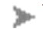Properties panel (Family Types).
- In the Family Types dialog, under the Parameters group box, click Add.
- In the Parameter Properties dialog, select Shared parameter.
- Click Select and choose the appropriate shared parameter from the appropriate parameter group. If desired, click Edit; this will return to the Edit Shared Parameters dialog which allow to open a different shared parameter file or to add new parameters (refer to the steps at Section 1.4).
- Choose whether to store the parameter by instance or type.
- Click OK. The parameter name appears in the Family Types dialog.
- (Optional) Enter a value for the shared parameter or create a formula to calculate its value.
1.3. Adding Shared Parameters in Revit Project File (BIM model .rvt)
- Start creating a project file or open an existing one.
- Click Manage tab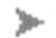Settings panel (Project Parameters).

- In the Project Parameters dialog, click Add.
- In the Parameter Properties dialog, select Shared parameter.
- Click Select and choose the appropriate shared parameter from the appropriate parameter group. If desired, click Edit; this will return to the Edit Shared Parameters dialog which allow to open a different shared parameter file or to add new parameters (refer to the steps at Section 1.4).
- Choose whether to store the parameter by instance or type.
- Select the categories to add the shared parameter on the right hand side.
- Click OK. The parameter will appear in the elements.
- (Optional) Enter a value for the shared parameter or create a formula to calculate its value.
1.4. Add new Shared Parameters in Edit Shared Parameters dialog
- Click Create.
- In the Create Shared Parameter File dialog, enter a file name, and save the dialog to a desired location.
- In the Groups box, click New and enter a name for the parameter group.
- From the Parameter group drop-down menu, select a group.
- In the Parameters group box, click New.
- In the Parameter Properties dialog, enter a name, discipline, and type for the parameter.
- (Optional) Under Tooltip Description, click Edit Tooltip. In the Edit Tooltip dialog, enter the tooltip text, up to 250 characters.
Creation of Project Information Attributes in Revit
In Revit, attributes for Project Information can adopt the default attributes of Revit file under Manage tab → Settings panel → Project Information. Below figure illustrates the default Revit attributes used for Project Information.
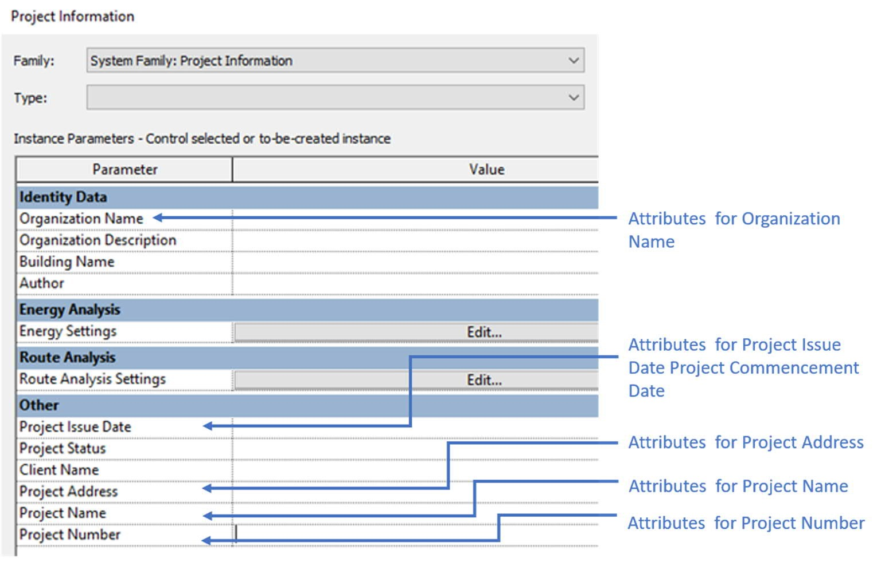
Creation of Material Attribute in Revit
In Revit, Family parameters for loadable families can be added as material attributes in the Family Editor. Key steps for adding a material attribute are described as follows:
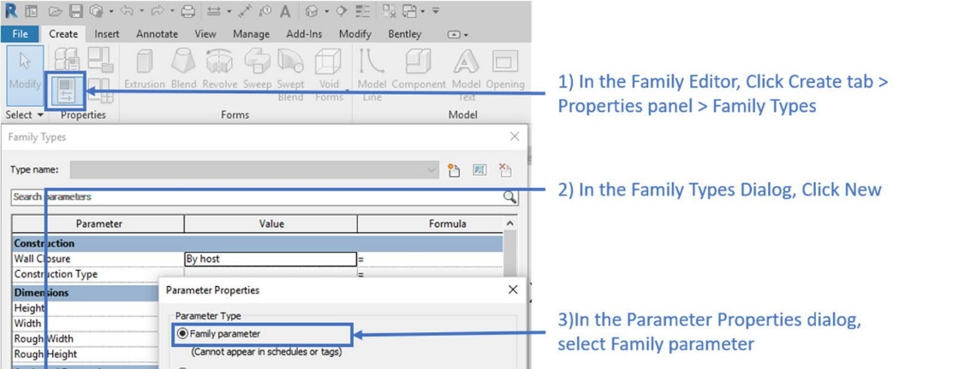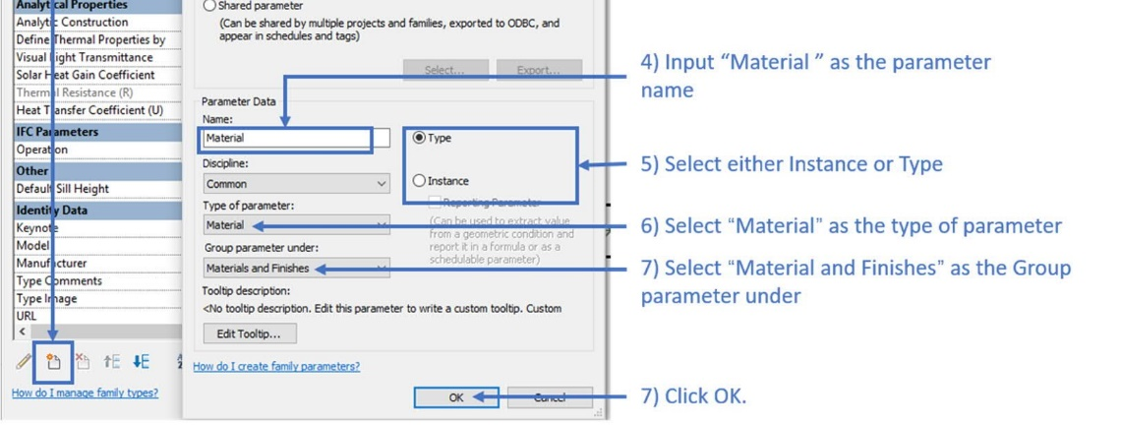
For Revit system families (e.g. basic ceilings, ramps), material should be set using the built-in “Material” parameter in the Type Properties dialog under Materials and Finishes. Refer to the image below for details.
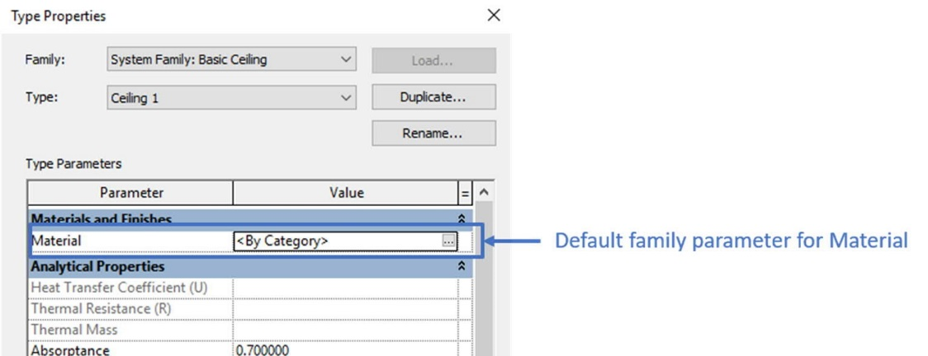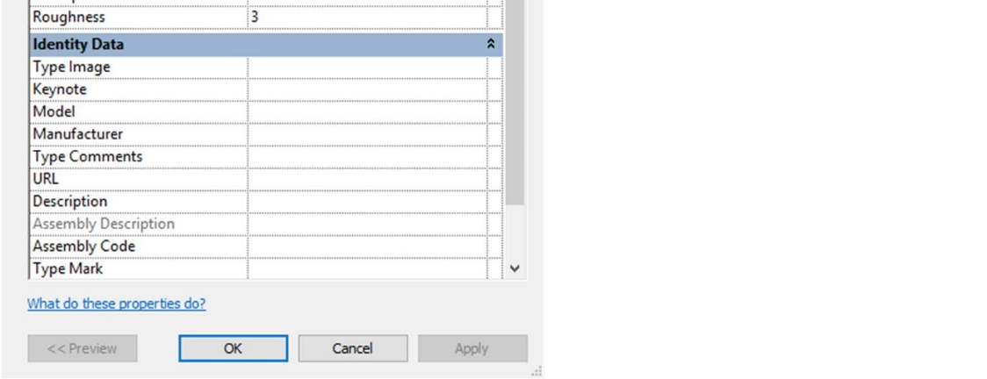

For compound structures, which are system families composed of parallel layers (e.g. walls, floors, compound ceilings and roofs), material should be set using the built-in “Material” parameter for each compound structure layer in the Type Properties dialog under Materials and Finishes
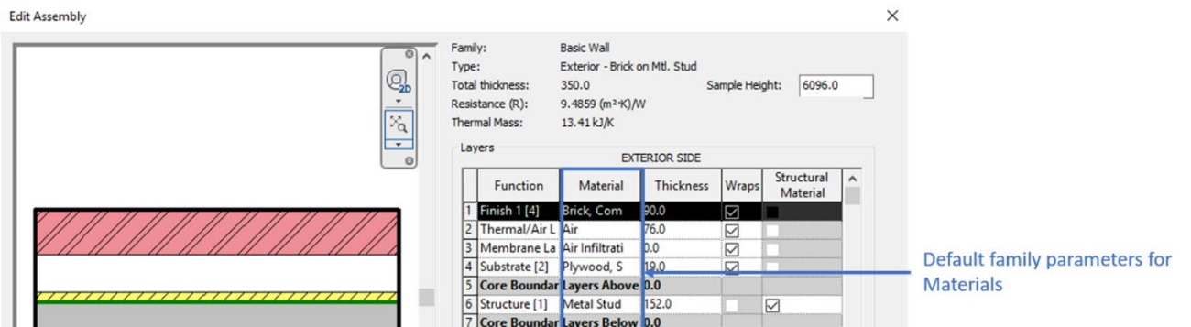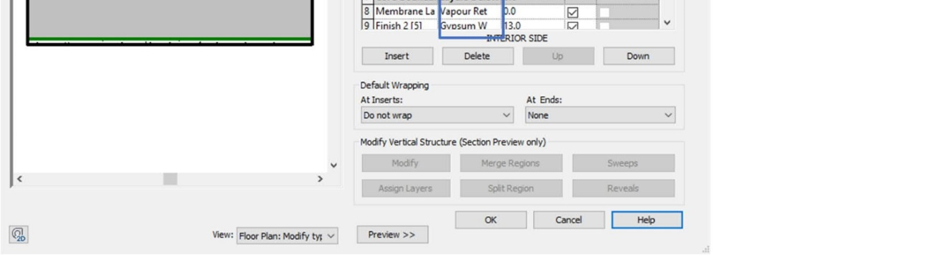

Filling in Default Attributes under Room in Revit
In Revit, Room objects already contain Name and Number as default parameters. The location of these attribute on “Properties” tab are described as follows:
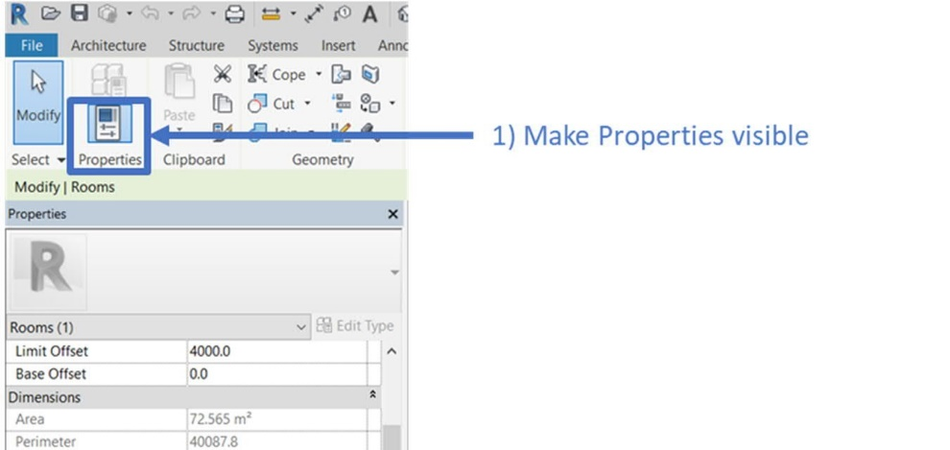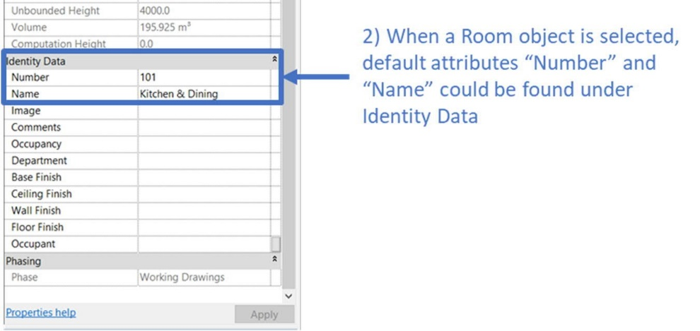

Autodesk Civil 3D Software
All attributes (LOD-I), including omni class code, title and version shall be added into Civil 3D Objects (object library) by Property Set. The following guideline provide a general guideline.
Creation of Property Set
In Civil 3D, Property Sets would be used for user-defined attributes for BIM model elements and Omniclass classification for Generic 3D BIM object (e.g Corridor solid). Below is an example of user-define attribute for pipe using Property Sets.
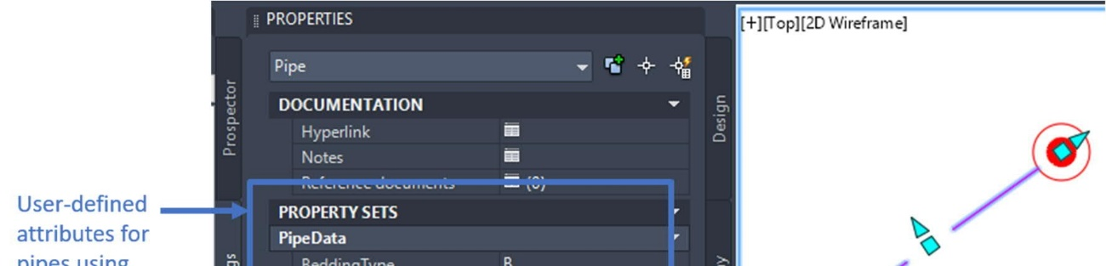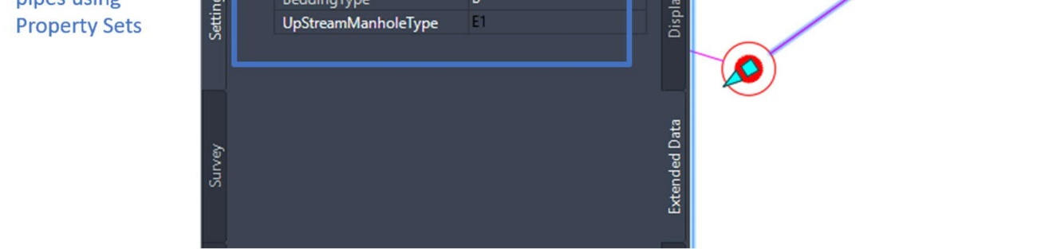
Property Sets could be defined in Style Manager. Following are the key steps for setting up Property Sets for user-defined attributes for Civil 3D BIM object.
  - Input command “STYLEMANAGER” at the command line to open the Style Manager which is shown as below image:
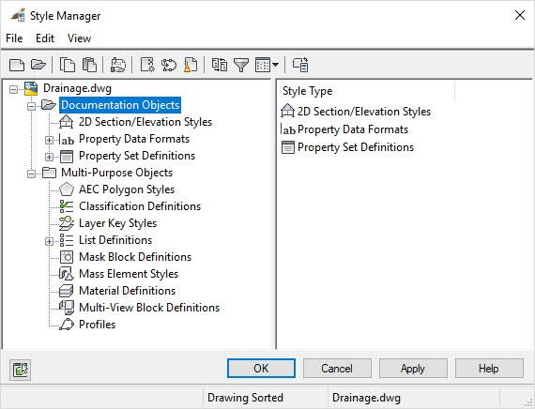

  - Under Style Manager, right click Property Set Definitions under Documentation Objects, then click New.
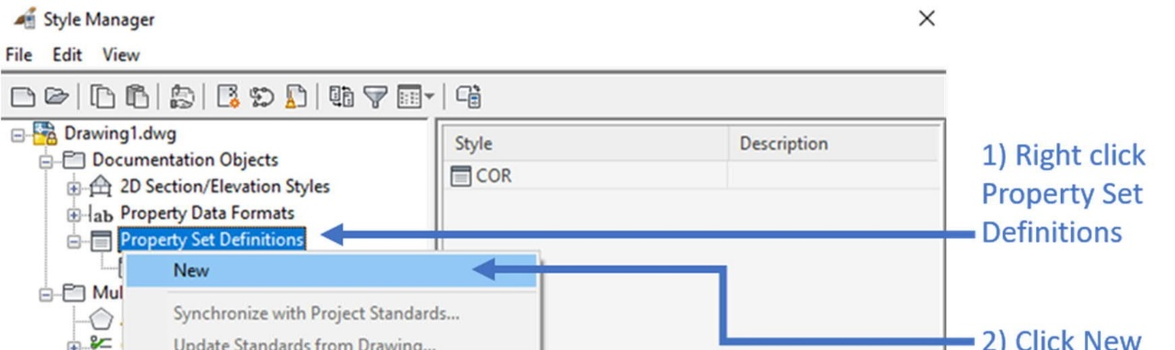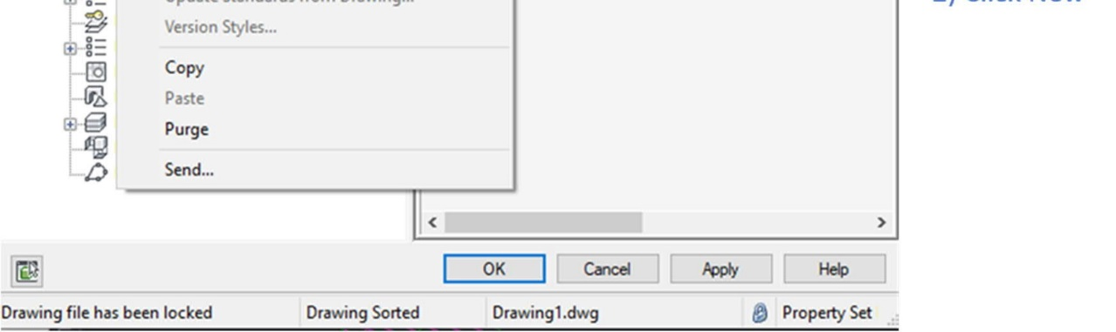
  - Input the Name and Description of the Property Set in General tab.
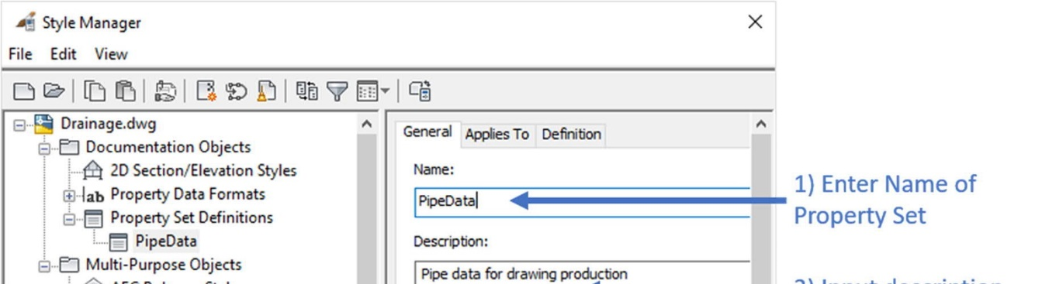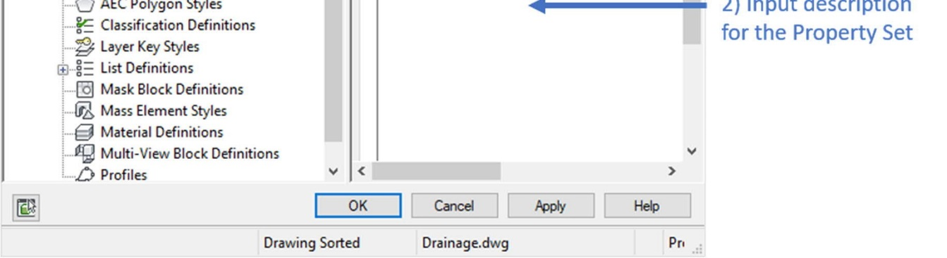

  - Under Applies To tab, select the types of object, eg, Pipe, to be applied in the Property Set.
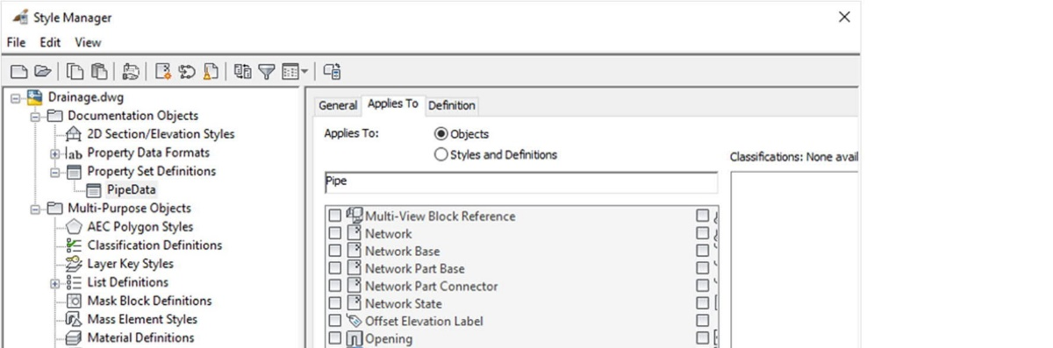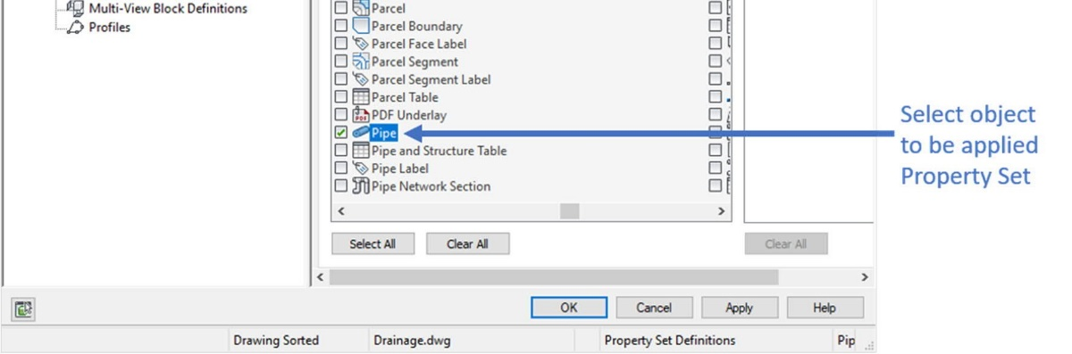

  - In Definition tab, click the properties as required to be added to the Property Set.
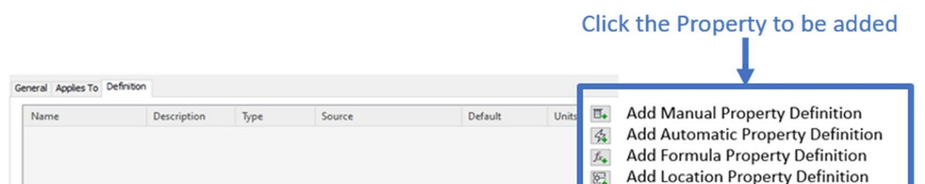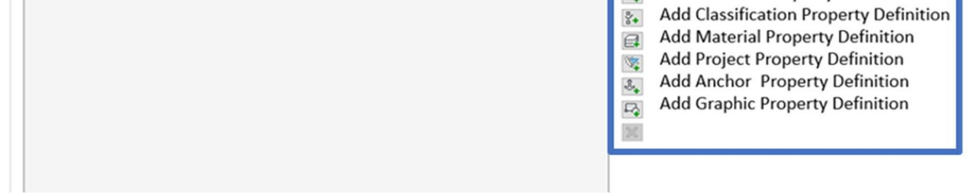

  - Edit the Name, Description, Type, Source, Default value, etc. for the properties.
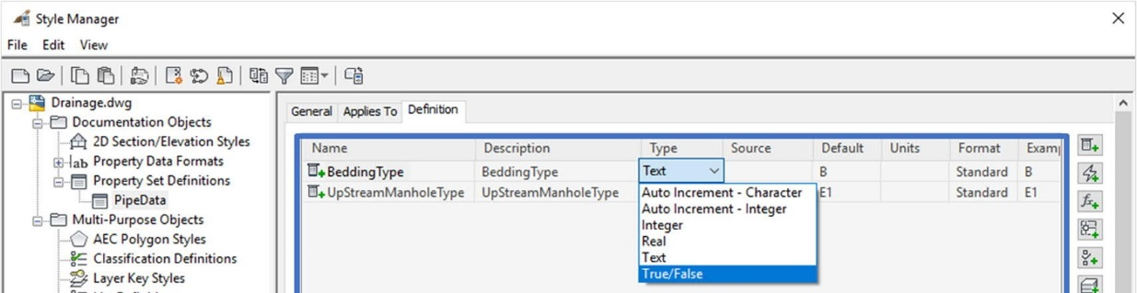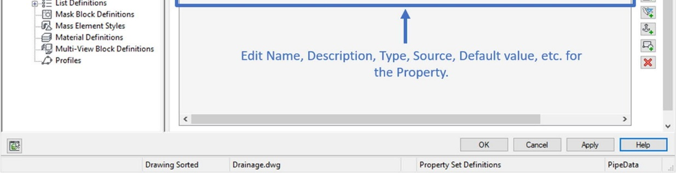
Define Omni Class information for Generic 3D Objects in Civil 3D
Properties Set should be used for setup OmniClass information for the 3D polyline and 3D solid objects, such Corridor solid, Site boundary under Style Manager, using property set. An example is shown below:

  - OmniClass Classification Properties
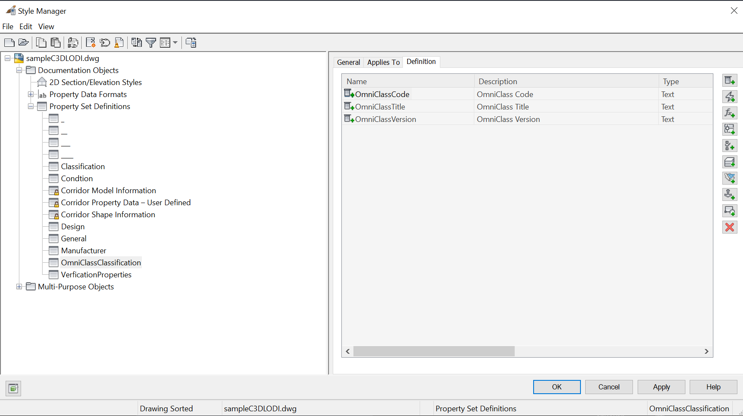

Define attribute information for 3D Objects/BIM Objects in Civil 3D
Properties Set should be used for setup attribute information for the 3D solid objects/BIM objects under Style Manager, using property set. The examples are shown below:

  - General Properties
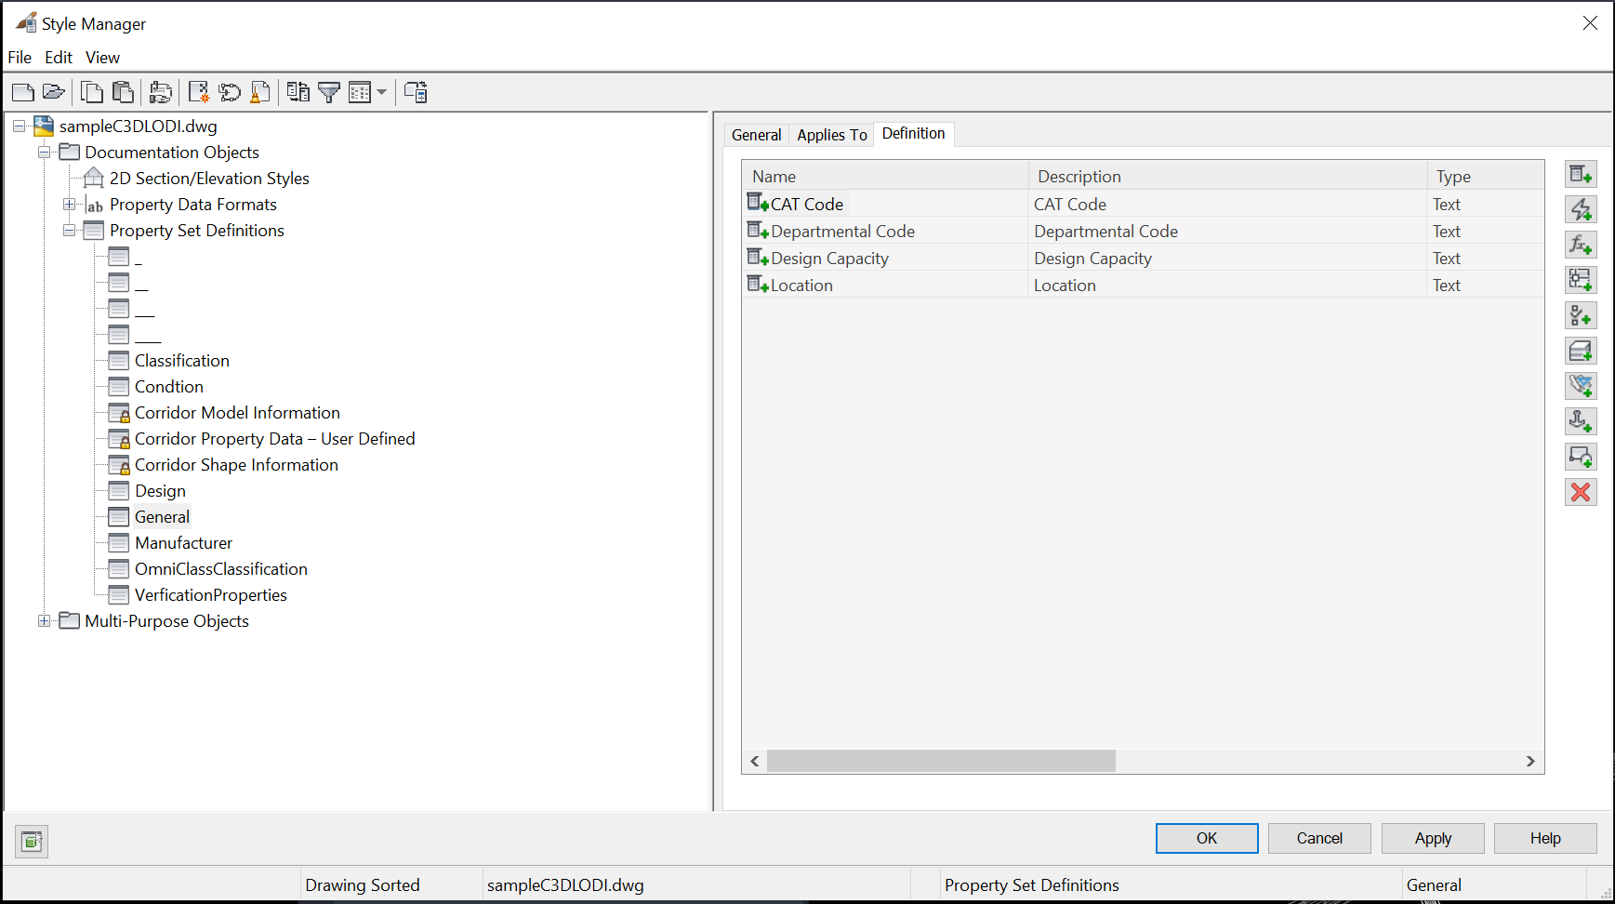

  - Design Properties
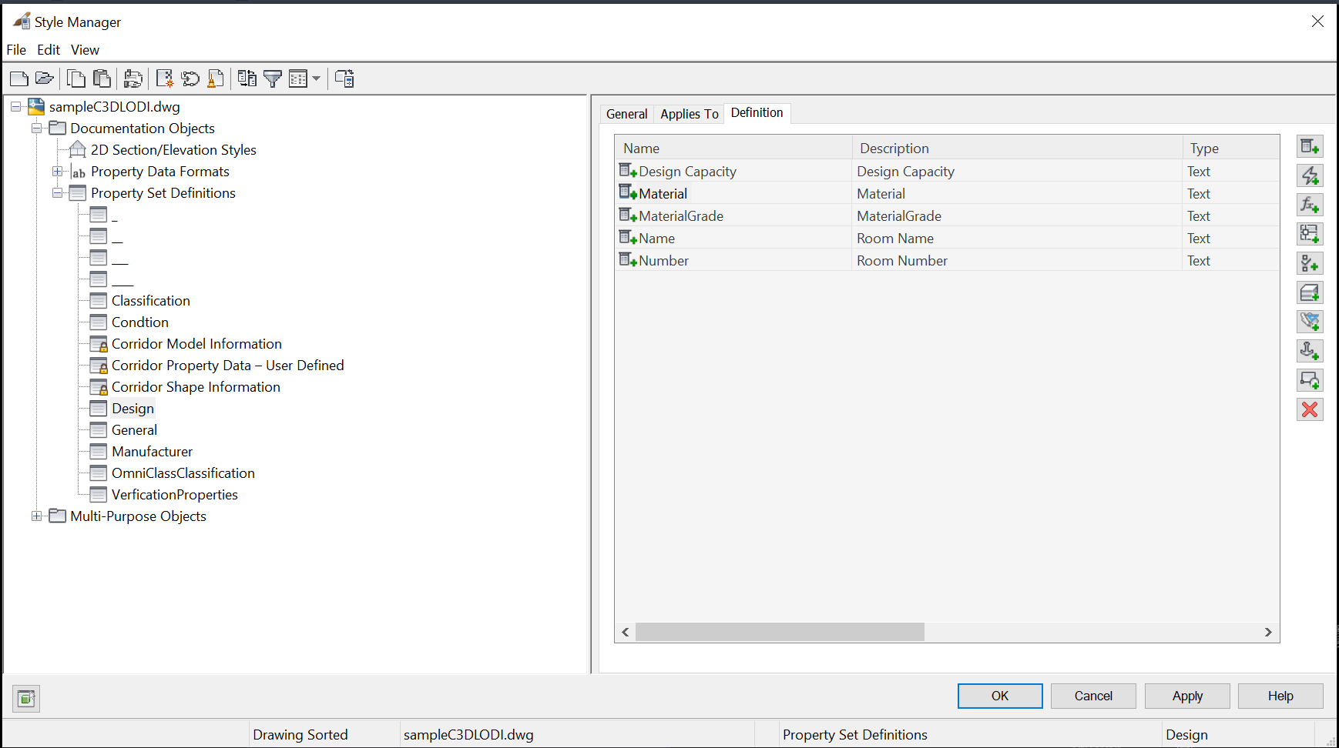

  - Manufacturer’s Properties
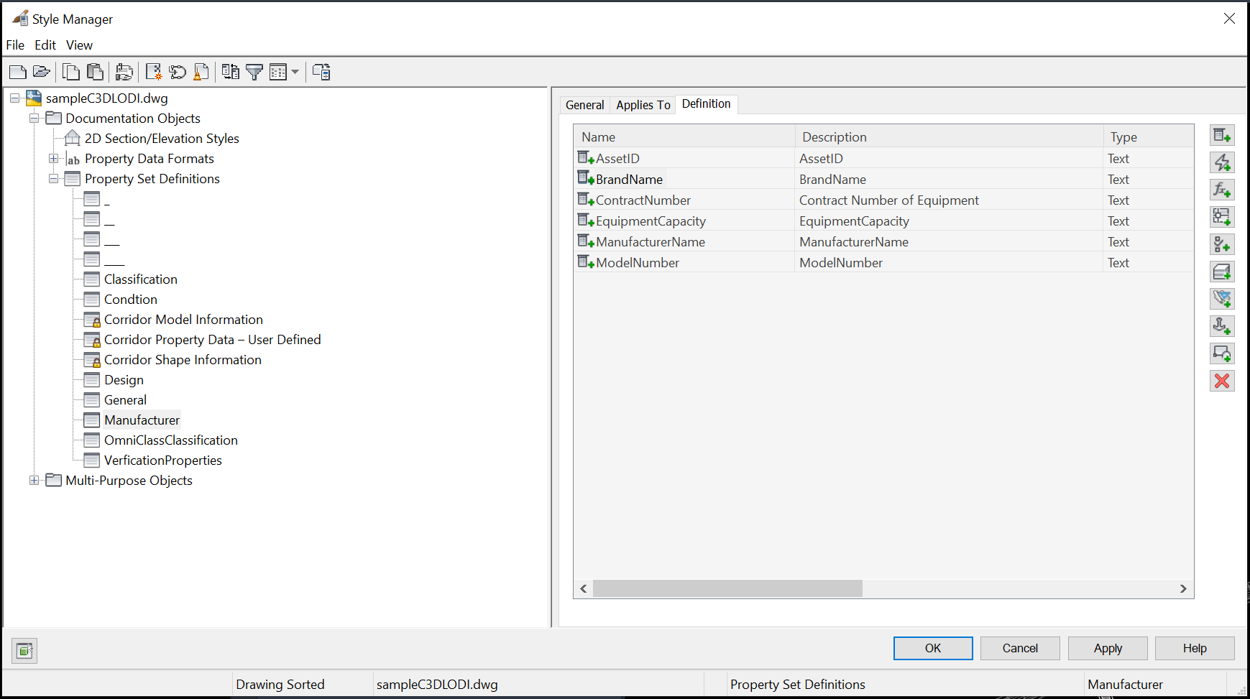

  - Conditon Properties
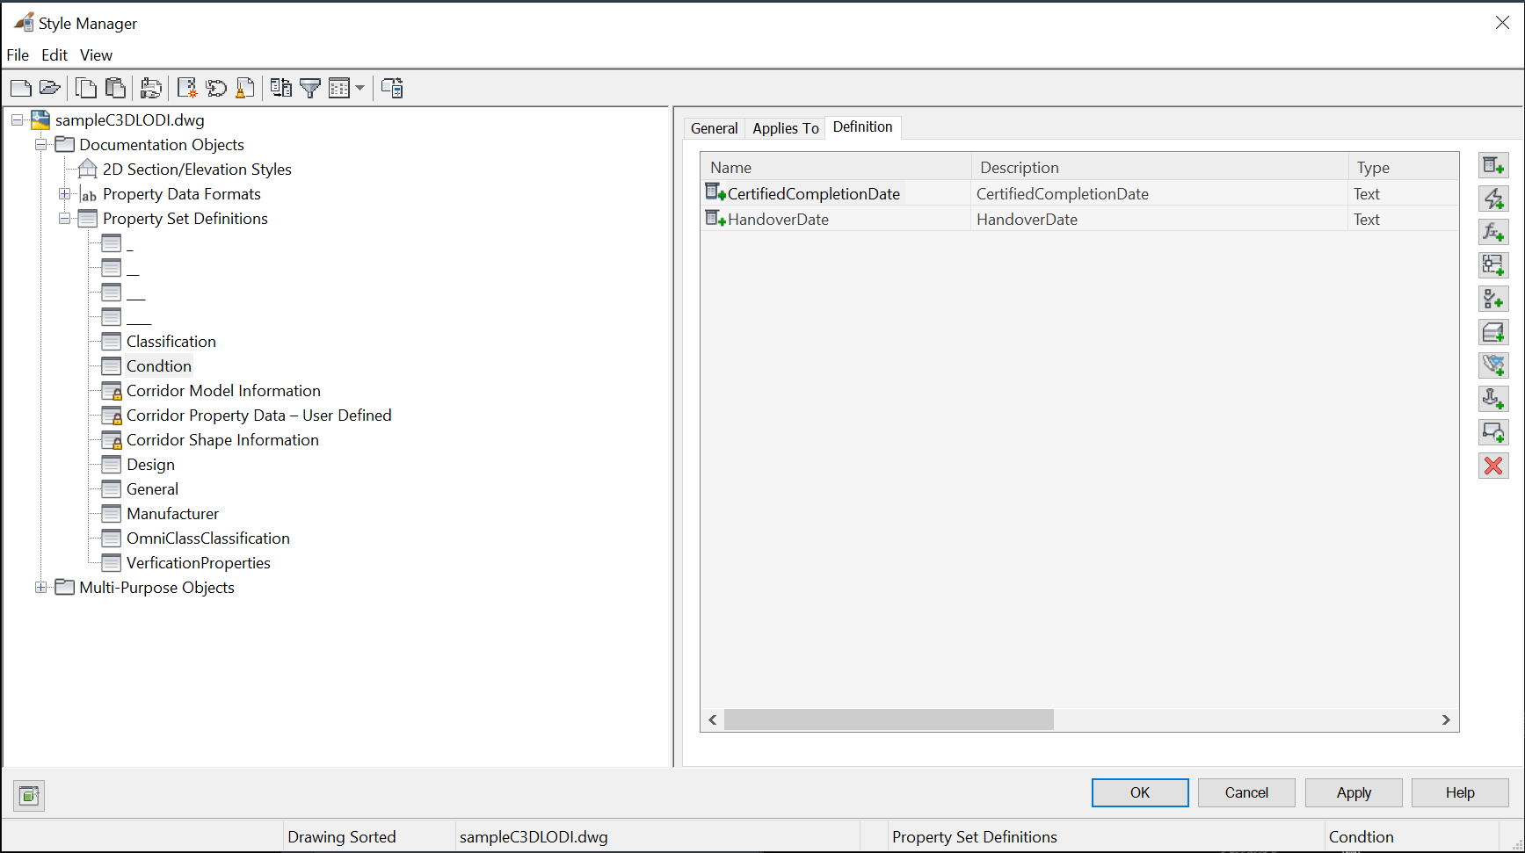

  - Verification Properties
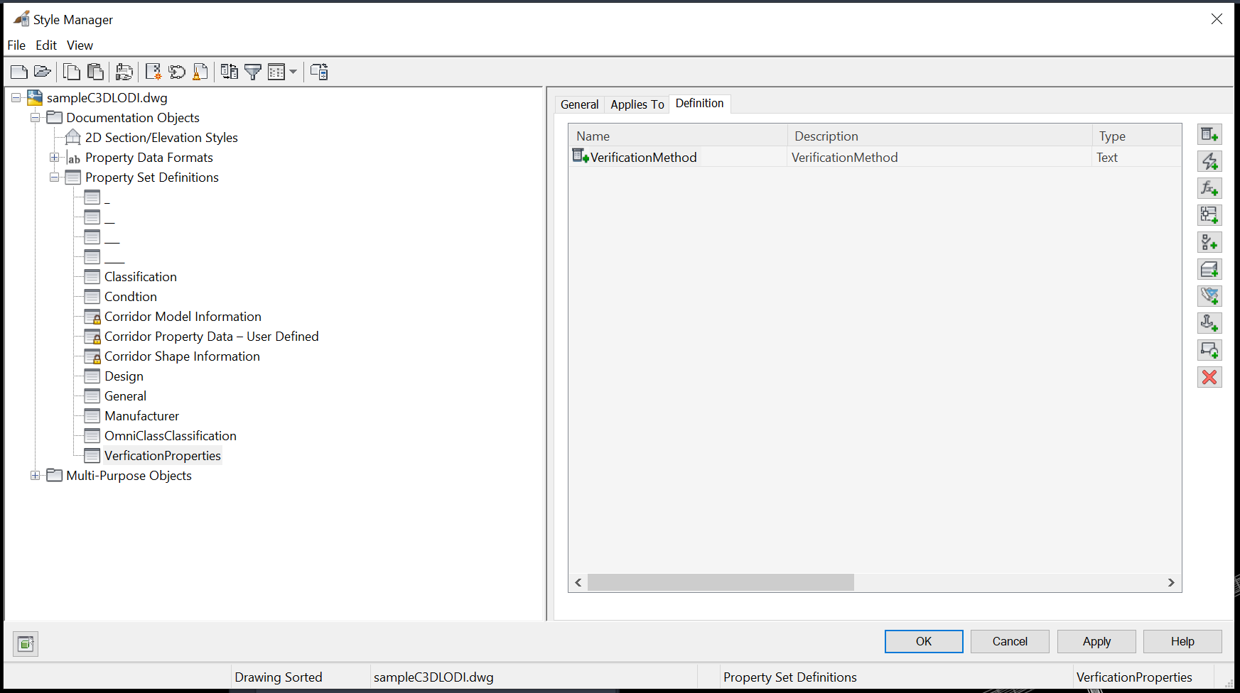
Application of Property Set
  - Select the model element, input PROPERTIES command in the command line, then click Extend Data in the PROPERTIES Palettes.
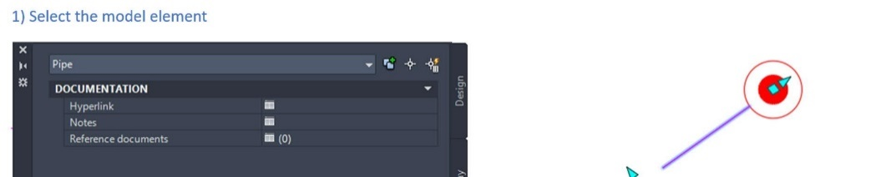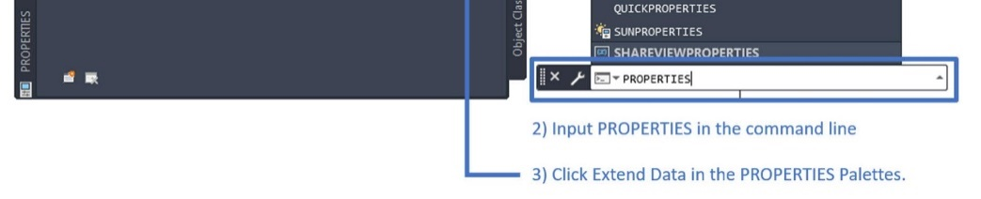
  - Click Add Property Sets icon in the bottom left of the PROPERTIES Palettes. In the Add Property Sets dialog, click to select the pre-defined Property Set “PipeData”, then click OK button.
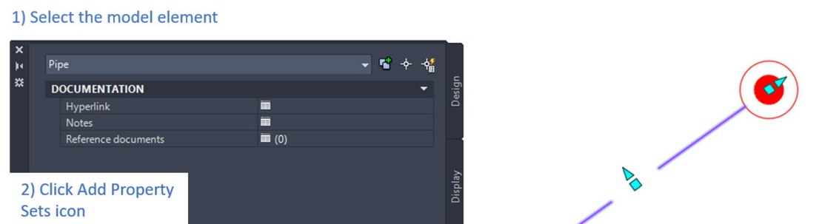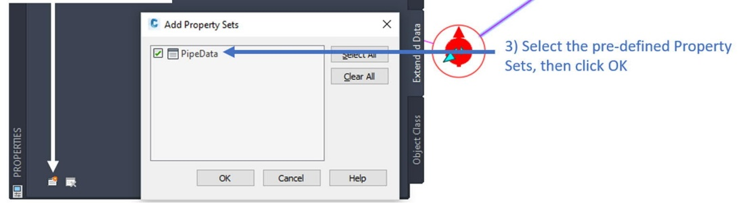
  - Then, the “PipeData” of Property Set has been added to BIM object shown as below image.
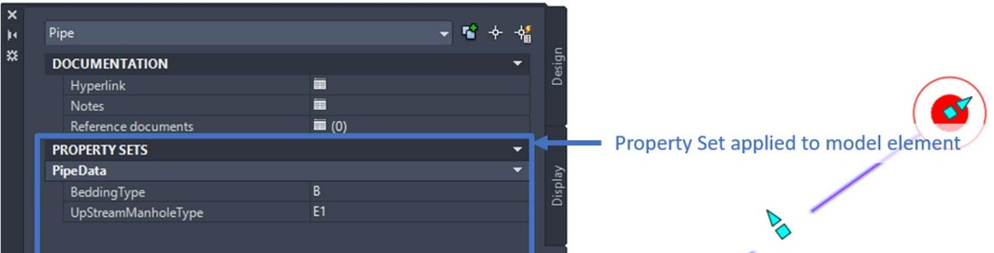
  - An example is shown below after the all attribute information are assigned to the 3D objects

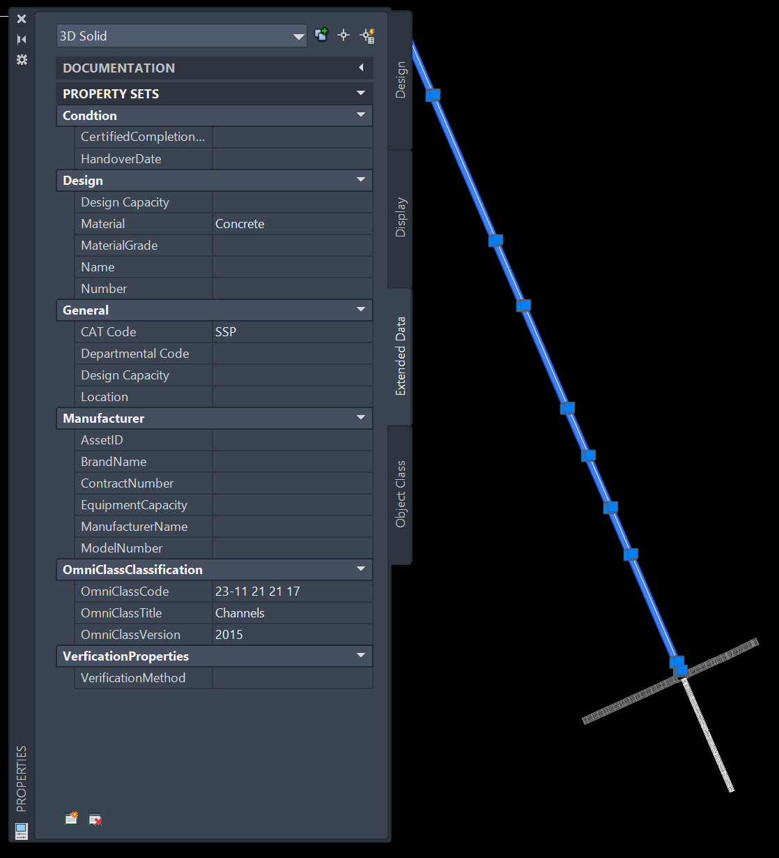

Define Omni Class information for Civil 3D BIM Objects
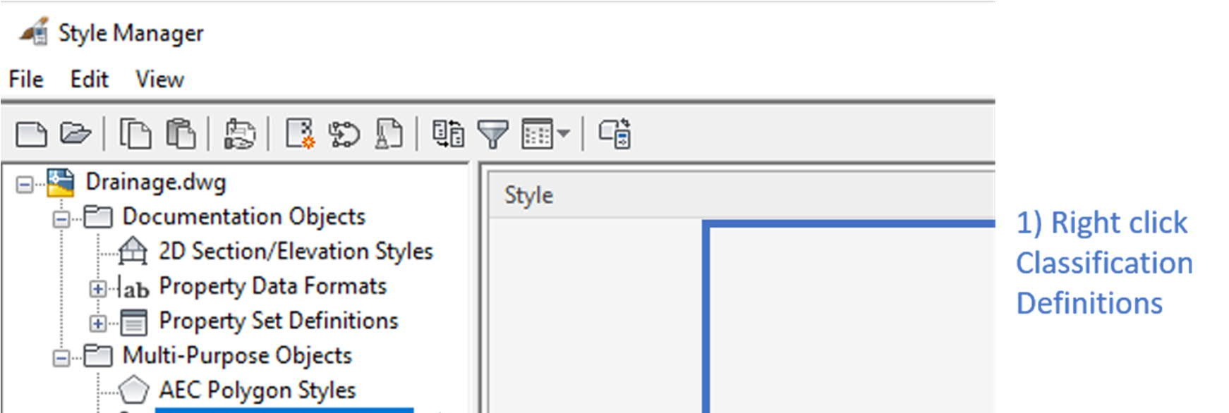
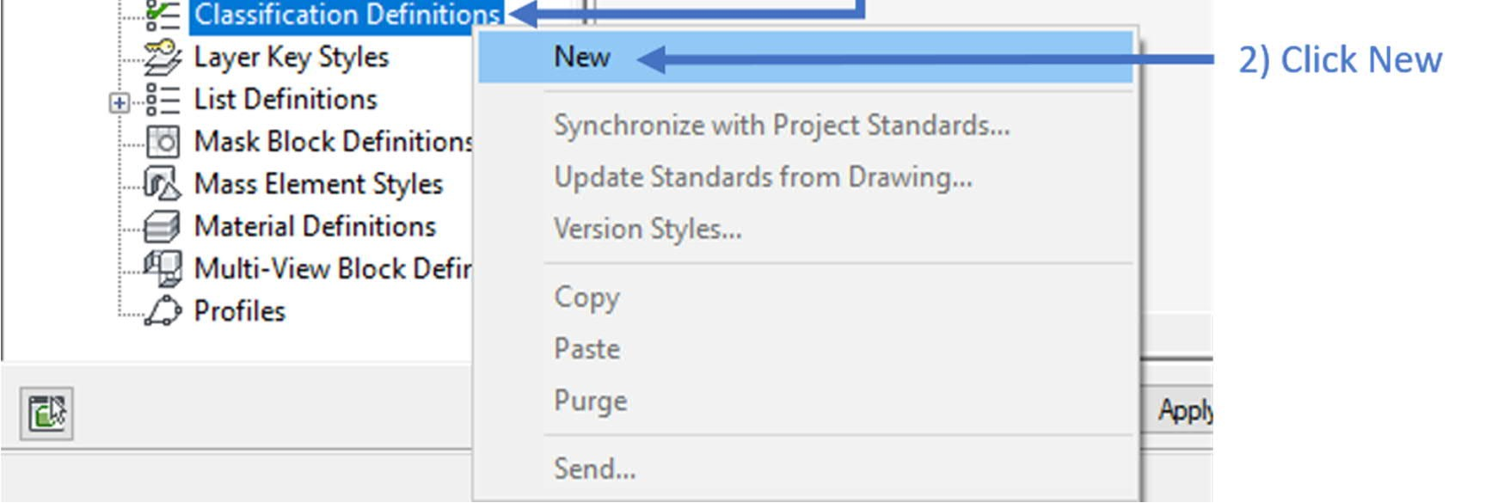
Classification Definitions should be used for setup OmniClass information for the Civil 3D BIM objects, such as TIN Surface, Corridor, Pipe and Pressure pipe objects under Style Manager.
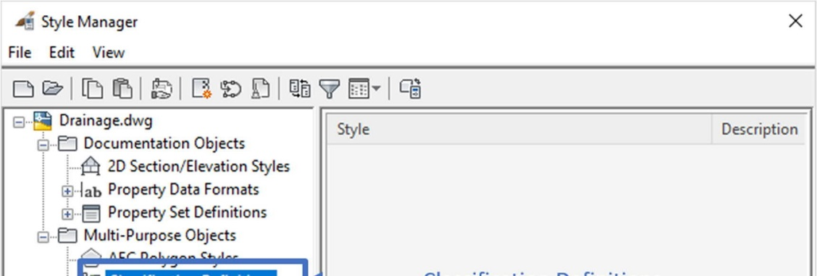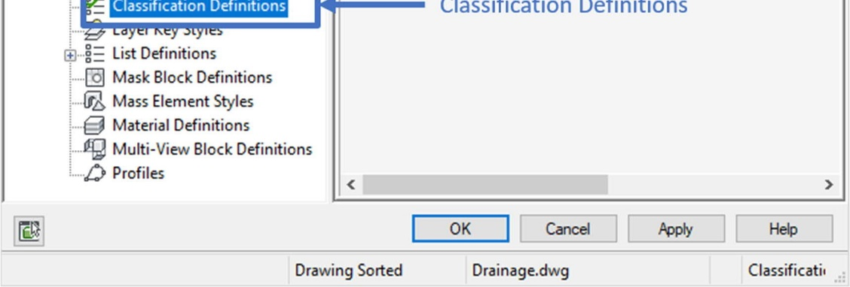

  - In the Style Manager, right click the Classification Definitions under MultiPurpose Objects, then click New to create new classifications.

  - In the General tab, enter the Name and input the Description.
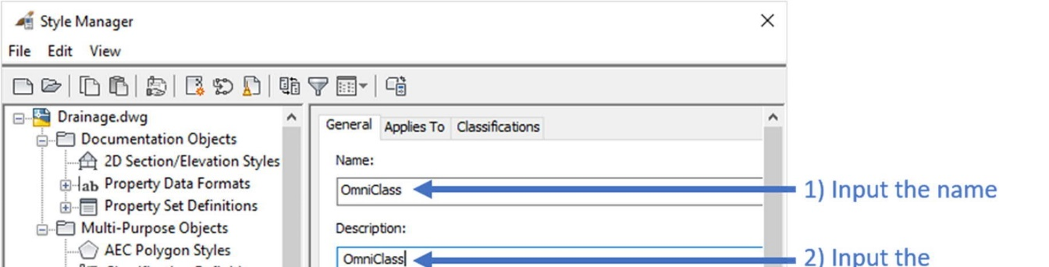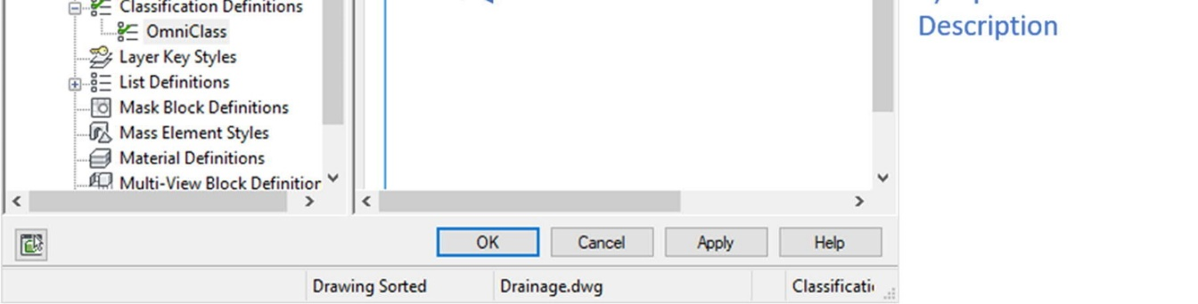

  - In the Applies To tab, select the BIM object with the OmniClass information.
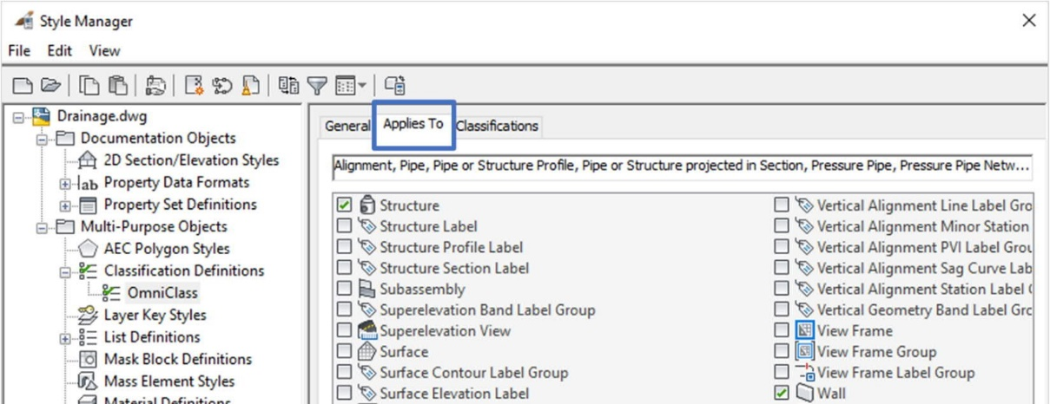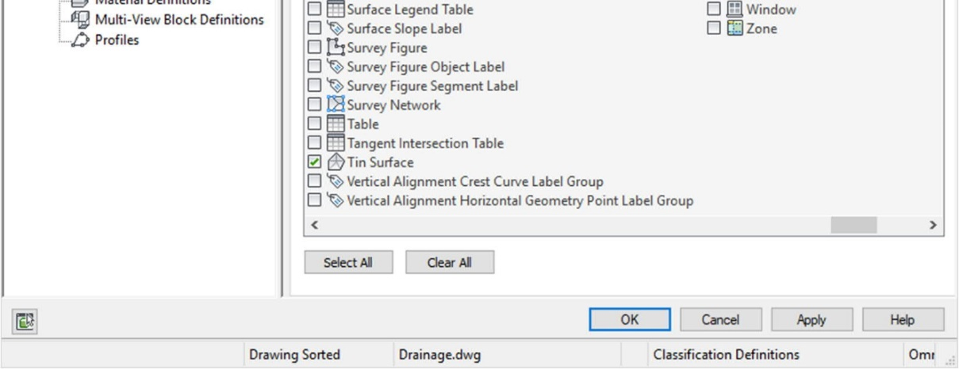

  - In the Classification tab, click Add to enter classification items which are Item and Description. “Item” is equivalent to OmniClass classification number while “Description” is equivalent to OmniClass classification title. Click OK button when classification information is entered.
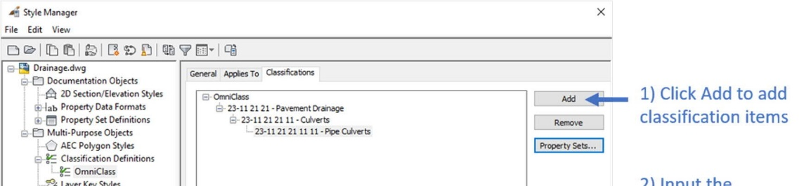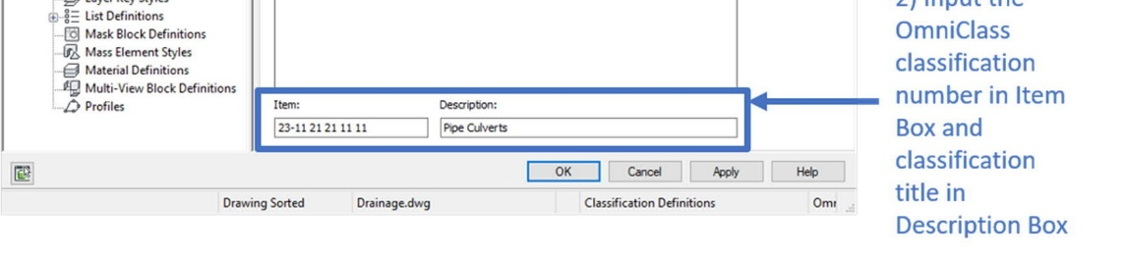
Apply OmniClass classification number to Civil 3D BIM objects

  - Select the BIM object, in the Extended Data tab of PROPERTIES Palettes, click “Unspecified”.
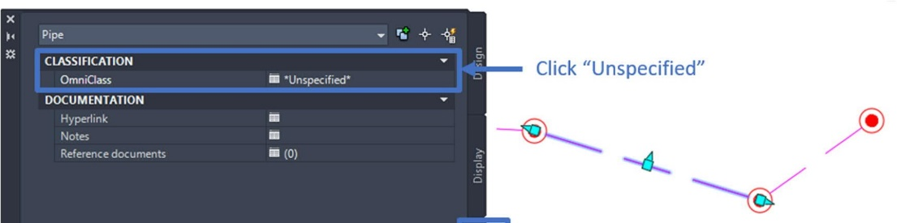

  - In the Select Classification dialog, select the pre-defined classification information, then click OK.
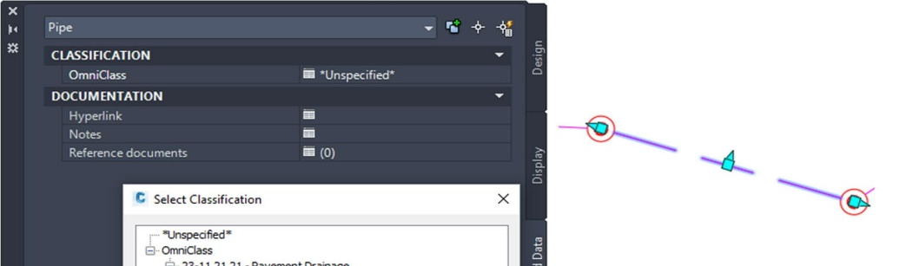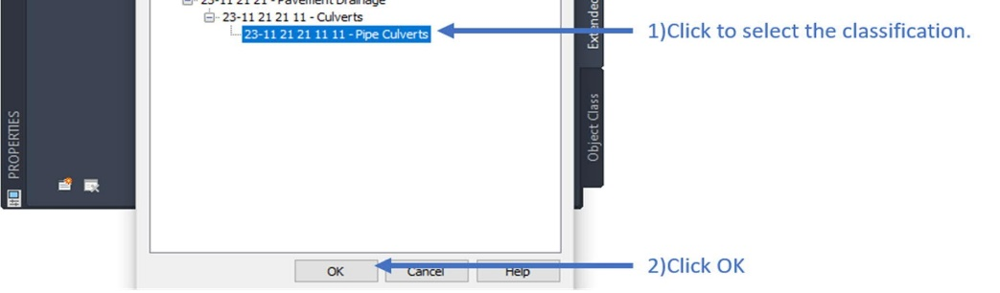
  - After the selection, the OmniClass classification number is shown as below image.
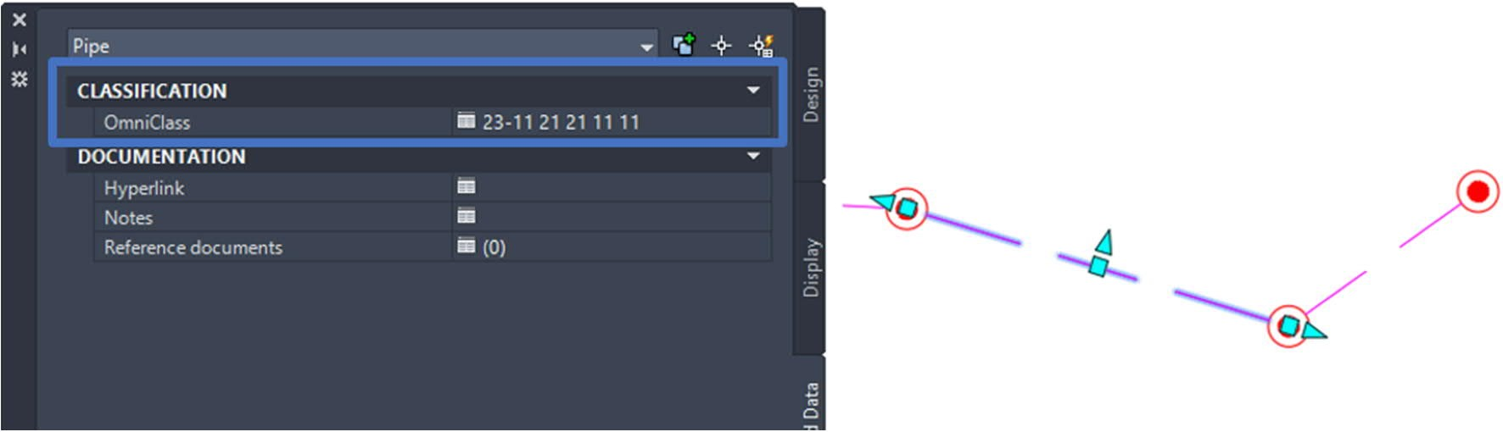

Creation of Project Information Attributes in Civil 3D
In Civil 3D, attributes for Project Information can be created by using Custom Property in Drawing Properties Dialog Box.
Project Information Attributes in Civil 3D
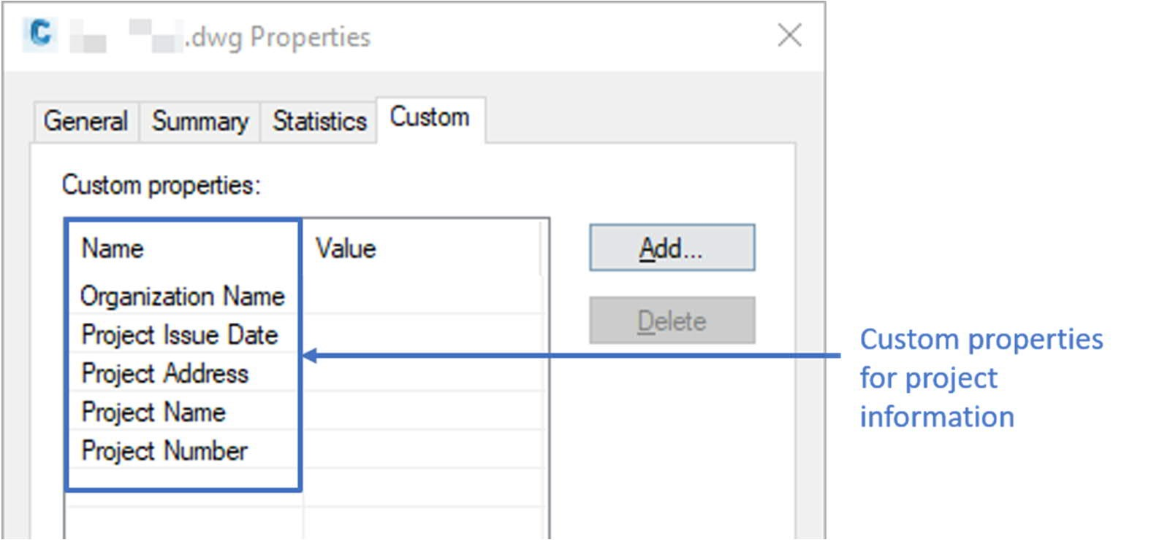
To create the Custom Property, first input “DWGPROPS” in the command line to show the Drawing Properties Dialog Box, then follow the steps as illustrated in below figure to add the attributes for Project Information.
Adding Custom Property Name in Civil 3D
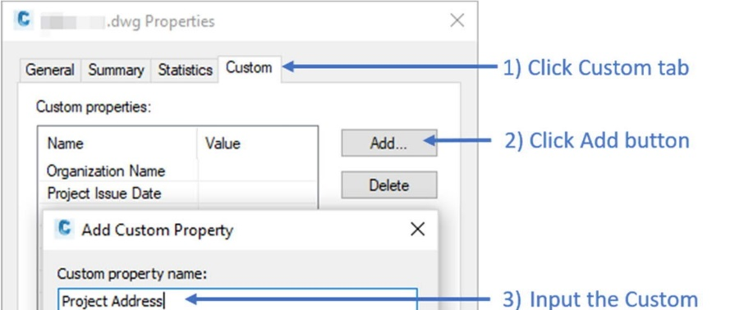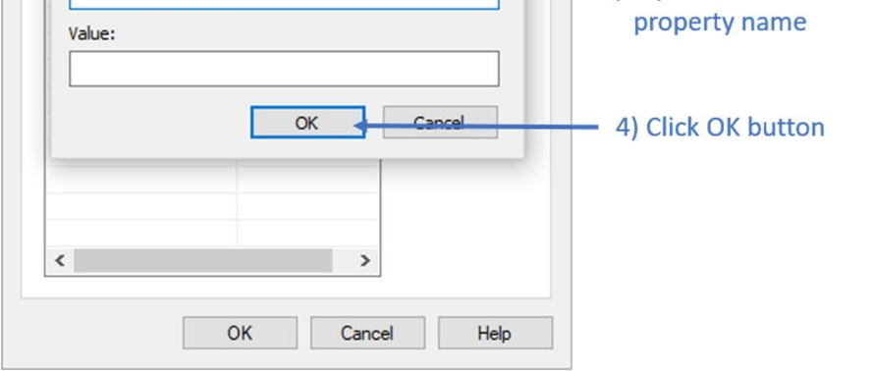

ANNEX B:
BIM OBJECT SHEET TEMPLATE

[BLANK PAGE]

 |  | QR Code for FM | SOFETWARE VERSION  YYYY | REFERENCE NUMBER
 |  | QR Code for FM | DATE  MM/YYYY | XXXX
BIM OBJECT SHEET |  | QR Code for FM | REVISION  XX

INPUT
BIM OBJECT NAME  XXXXXXXXXXXX | BIM OBJECT CATEGORY  XXXXXXXXXX | LOD  XXX | 3D GEOMETRY
PLAN | 3D |  | 3D GEOMETRY
FRONT ELEVAION | PROPERTY / PARAMETER |  | 3D GEOMETRY
SIDE / SECTION ELEVATION |  |  | 3D GEOMETRY

2D SYMBOL NAME  xxx |  | 2D SYMBOL | 2D TAG / LABEL / ANNOTATION NAME  xxx | 2D TAG / LABEL / ANNOTATION
REMARKS | xxx

PURPOSE/ VALUE DRIVEN BIM OBJECT DELIVERABLES

OUTPUT
SHEET VIEW: PLAN | SHEET VIEW: ELEVATION
 |  |  | PRESENTATION DRAWING
STATUTORY / AUTHORITIES
SUBMISSION DRAWING
TENDER / CONSTRUCTION
DRAWING
 |  |  | SCHEDULE IN DRAWING

[BLANK PAGE]

The BIM Team shall refer to the “Appendix IV – Master Type List” in BIM Harmonisation Guidelines for the exact coding.
[Note: To facilitate the review purpose, the codes not available in the BIM harmonisation guideline are highlighted in Yellow]
The BIM Team should further detail the Omniclass classification to Level 3 according to the actual type of finishes used on site
The BIM Team should further detail the Omniclass classification to Level 3 according to the actual type of finishes used on site
The BIM Team should further detail the Omniclass classification to Level 3 according to the actual type of sensors installed on site
Addition codes are included and highlighted in the table
Addition codes are included and highlighted in the table

