Hardware and Software and Collaborative Platform Specifications

- Minimum hardware requirements for creating BIM models
The project team will ensure the suitability of servers, workstations and network connectivity (both internal and external) to meet the minimum specifications of the adopted BIM tools and allow for software upgrades during the progress of the project.
Appropriate backup solutions must be in place to ensure data loss is kept to a minimum in the event of catastrophic failure or data corruption. Workstation capability reviews and their effect on model performance has been made part of the standard agenda in the BIM Coordination meetings.

Item | Hardware
1. | The following are the minimum hardware requirements for creating BIM models, families and assemblies:  - Intel Core i7-7700 @ 3.60GHz or equivalent AMD Athlon ® processor  - Microsoft® Windows 7 Pro 64-bit  - 64GB RAM  - 1TB free disk space  - GeForce capable graphics card with GTX900 series, GTX 1050, GTX1060 or later  - Video display 1,280x1,024 with true colour  - Internet connection for communication with project team  - Two-bottom mouse with scroll wheel  - Microsoft® Internet Explorer® 8.0 or later

- Software for BIM Use
The following software choices have been established to deliver the prioritised BIM objectives. Any software version changes and updates must be explicitly agreed by design team, contractor (post tender) and the BIM Manager before implementation.
BIM Use | User | Software | Version
Design Reviews | ARC/CIV/ STR /BSE/CON/FAC/ Client | Revit / Fuzor / Design Review | 2019
Design Authoring | ARC/CIV/ STR /BSE/CON/FAC/ | Revit | 2019
Spatial Planning | ARC | Revit | 2019
Libraries of assemblies / systems / components | ARC/CIV/ STR /BSE/CON/FAC/ | Revit | 2019
3D Coordination | ARC/CIV/STR /BSE/CON/FAC | Fuzor | 2019

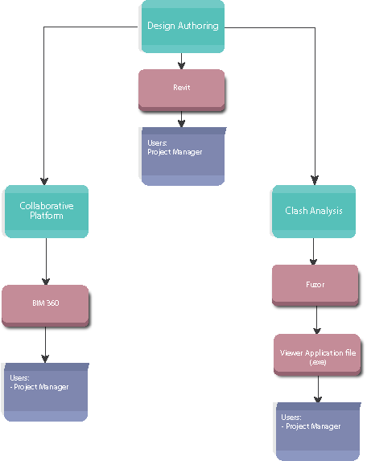
The following diagram shows the software that SHK Project Manager are needed in this project.

The following diagram shows the software that BIM discipline lead are needed in this project.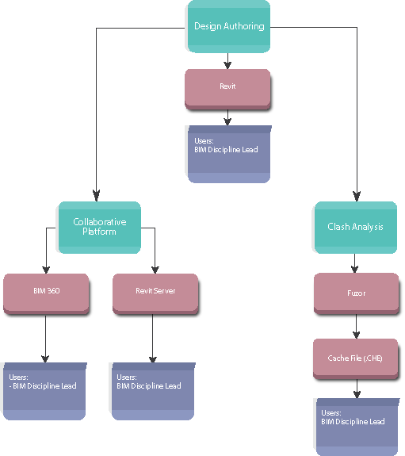

- Collaborative Platform (BIM360 Docs)
Collaborative Platform | BIM360 Docs
Objective | BIM 360 Doc is a collaboration platform for different parties to review the combined BIM model and make the comment in short time. This platform can also control work sharing at user, role, company, file- or folder-level.
Function | - Controlled sharing of information across the entire team  - View, share and review over 50 2D and 3D file formats.  - Create mark up and redlines on the model.  - Explode the model.  - Section analysis on the model.  - Compare the version of 3D model to review the design change.  - Manage contract documents and track project activity  - Access files on the computer and mobile device through BIM 360 Team mobile application.
As BIM 360 Team no longer available for collaboration, a new platform call BIM360 Docs is suggest using for this project. The new platform offers data management and collaboration functionality. The price and the function of BIM360 Docs and BIM360 Docs is different

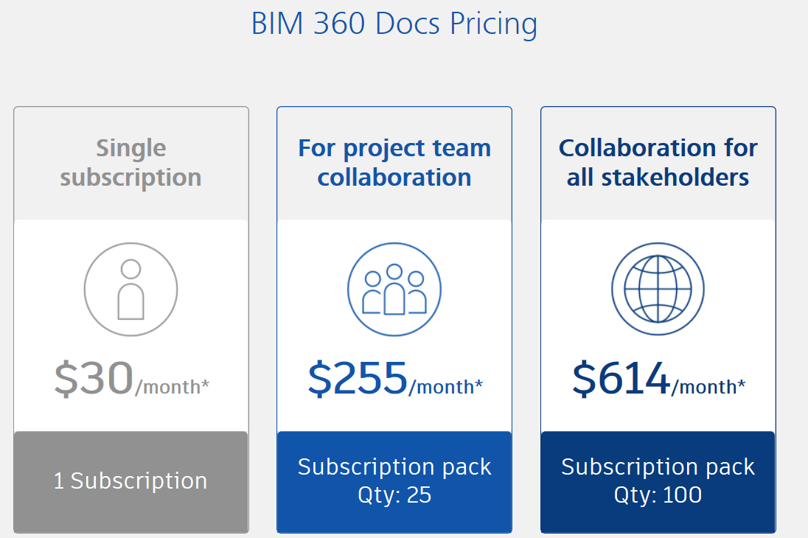

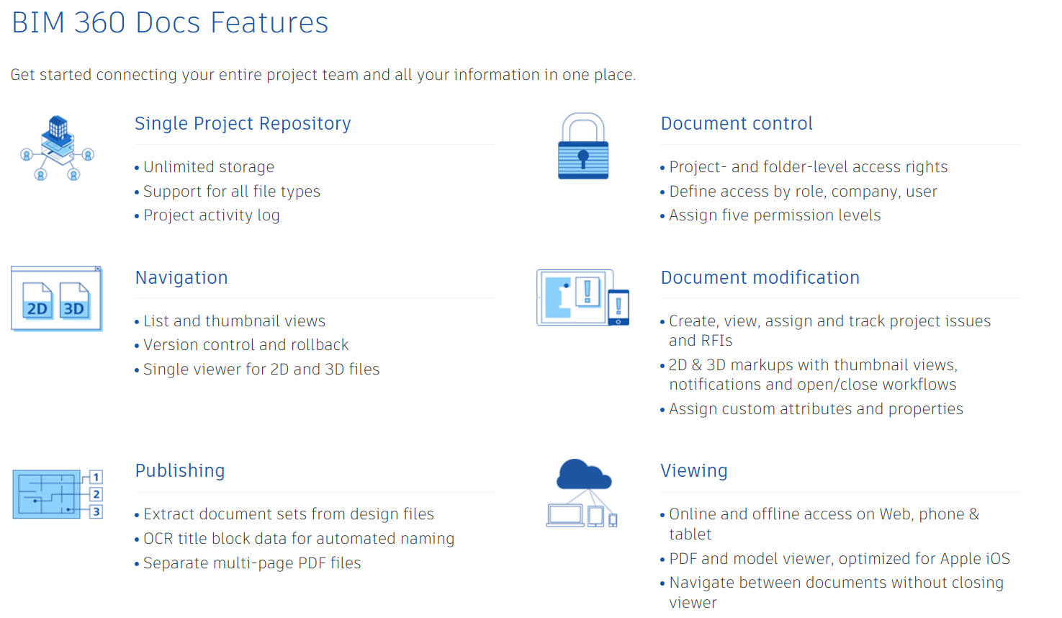

- Collaborative Platform (Common Data Environment)

 | Revit Server
Cost | The cost is mainly divided into 5 parts:
Cost |  | Year 1 | Year 2 | Year 3
Cost | - Hardware cost | Total estimated $100,000.
Cost | - Server Software cost | Total estimated $100,000.
Cost | - Cost for IT set up port | Say $20,000.  (Subject to quotation from related I.T. company.)
Cost | - Maintenance cost | Say $5000 per month ($5000x12=$60,000) | Say $5000 per month ($5000x12=$60,000) | Say $5000 per month ($5000x12=$60,000)
Cost | - Set up cost of accelerator for the parties to connect the Revit Server. | Allow $30,000 for each party  ($30,000 X 5 parties =150,000)
 | Total: |  |  | $450,000
Minimum hardware requirements | - Up to two Intel® Xeon® processors E5-2600 v3 seriers with up to 18 cores each / up to 45MB per processor  - Up to 1.5 TB with SK Hynix 64 GB TruDDR4 Memory LRDIMMs; System supports RDIMM/LRDIMM  - Up to 24 front and 2 rear 2.5-inch HDDs/SSDs; or up to 12 3.5-inch and 2 rear 3.5-inch HDDs + 2 rear 2.5-inch HDDs/SSDs; or up to 8 3.5-inch HDDs and 2 rear 3.5-inch or 2.5-inch HDDs/SSDs (model dependent)  - 12 Gbps dedicated slot for the first RAID; support for up to four RAID adapters  - Up to 1/2 redundant 550 W AC, 750 W AC, 900 W AC, 1500 W AC, 900 W DC 80 PLUS® Platinum, or 750 W AC 80 PLUS Titanium  - Power supplies, fan modules, and HDDs/SSDs  - 4 x 1 GbE (std) and 1 x IMM; optional 10/40 GbE ML2 or PCIe adapter; Trusted Platform Module built-in  - 1 – 8 PCIe 3.0 slots (supports up to 2 x 300 W GPUs and up to 1 x ML2) and 1 dedicated RAID slot  - Up to 3 front (1 x USB 3.0, 2 x USB 2.0) and 4 back (2 x USB 3.0, 2 x USB 2.0) and 1 internal (USB 3.0) for hypervisor/1 front and 1 back  - Up to 100 TB storage space  - 80 PLUS® Platinum, 80 PLUS Titanium; ENERGY STAR compliance (model dependent)  - IMM2.1; one IMM dedicated port and one shared; optional remote presence; Predictive Failure Analysis; LEDs; optional next-gen light path diagnostics panel  Microsoft Windows Server, Red Hat Enterprise Linux, SUSE Linux Enterprise Server, VMware vSphere (Optional USB Key or SD Media Adapter
Objective | Revit Server is a common data environment that BIM coordination team can have better communication and tracking of required changes to the design. The transfer file should be linked to central file for different disciplines.
Function | - Upload central file and download the linked file from other parties.  - Different parties can work closely on the same area by using Revit’s linking function.

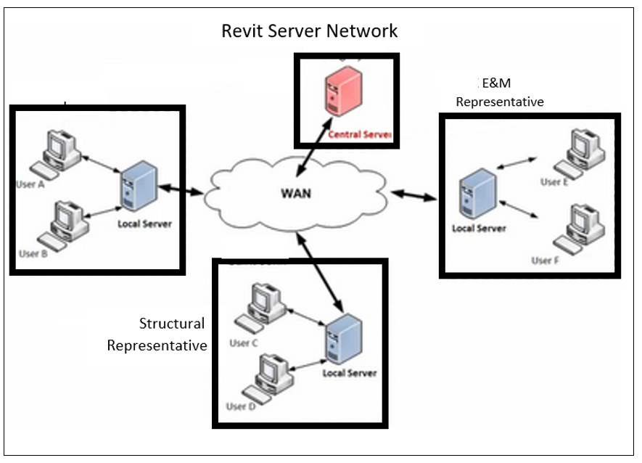

- Clash Analysis (Fuzor)
 | Fuzor Utimate 2019
Requirements | The program below should be installed before opening the Viewer Application File  Microsoft Visual C++ 2010 Redistributable Package (x64): http://www.microsoft.com/en-us/download/details.aspx?id=14632  - DirectX End-User Runtime Web Installer: https://www.microsoft.com/en-us/download/details.aspx?displayLang=en&id=35
Objective | Clash analysis shall be performed and reports produced and categorised in a log to be maintained by BIM Manager. during the consultancy using the Fuzor platform. Detailed clash analysis reports and Viewer Application File (.exe) shall be submitted to SHK at regular intervals during the project in accordance with the deliverables to review if the design is coordinated amongst various disciplines.  BIM Manger will conduct BIM Coordination Meeting at regular intervals during the project to record the progress of the model, the status of the clashes raised and will highlight all matters of issue or concern relating to the coordination of the models.
Function | - Clash results will be classified as major clashes if they affect the design of the structure of the building. For example, if a duct doesn’t have enough space in a given area, the design consultant may need to modify the ceiling heights.  - A minor clash will only need a minor change and can be accommodated without affecting other systems. For example, shifting a pipe location to avoid clashing with another element.

