

Geometry
Property
Symbol
Tag
- Acceptable
- Reject
A
- Outstanding
R
O
- Inapplicable
N
- Visibility Control
Suitable setting?
Hide unnecessary geometry on plan and section view?
- Symbol Drawing Production
Is symbol readable when printing out in appropriate scale?

- Symbol Orientation
If necessary, can the symbol orientation be controlled?

- Symbol Text
Can the text be displayed in project environment?

- Symbol Size Dependency
Can the symbol follow the change of the 3D geometry?

- Symbol Offest
If necessary, can the symbol offset adjustable?
- Maintenance Space
Does it require maintenance space?
Is space conformed to local practice?
- Insertion Point
Is the insertion point appropriate?

BIM Object Name |  | Ref. No.
Date |  | Assessment | APPROVED/ DISAPPROVED/  RESUBMIT
Inspector |  | Signature
Comment:
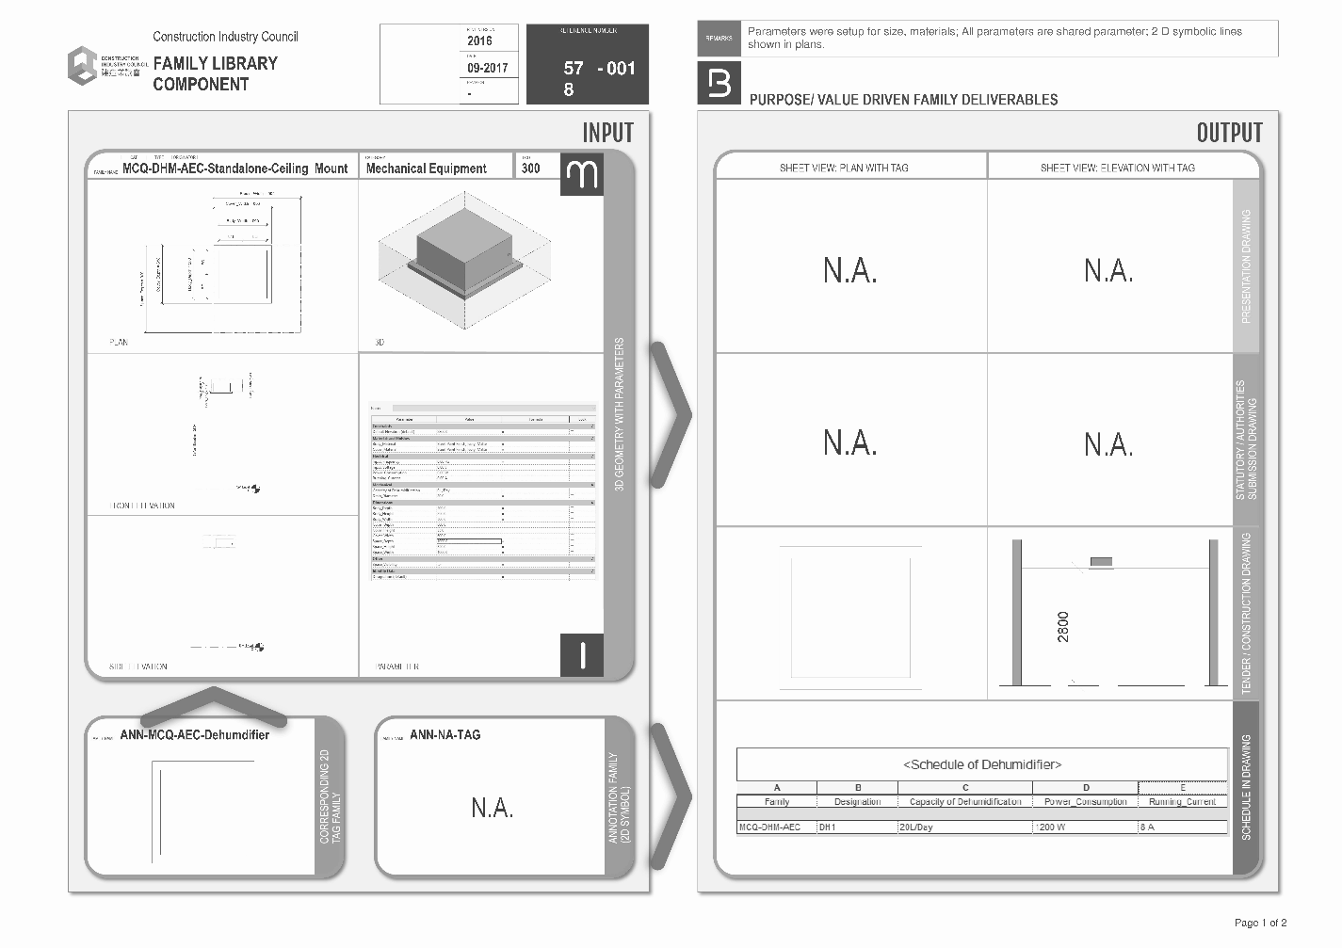
- Property Management
Are properties classified in suitable grouping and naming?

- Property Information
Is all information necessary or exhaustive for the user?

- Unit
Is project unit correct?
- File Size
Is it too large?
- Tag Drawing Production
Is it readable when printing out in appropriate scale?
- Parametric
Is it necessary to be parametric?
Is parameter behavior as expected?
- Category
Is the BIM object of correct category?
- Tag
Is the tag conformed to local practice or client requirement?

- Symbol
Is the symbol conformed to local practice or client requirement?

